**Technical Report**

Template

Student Name: Carlos Camacho

Date:2024

Part 1 Program and Design Specification 3

Program Specifications Report 3

Application Logic Requirements 3

User Interface 3

User Interface Sketches 4

Colour Scheme 4

Design Scheme 4

Part 2 User Interface Design Plan 5

Email to the client 5

Feedback from the Client/Teacher 5

User Interface Plan 5

UI sketch for each planned page or form 5

User Experience (UX) flowchart 5

Interaction Design Patterns 5

Client-Side validation techniques that will be implemented 5

Plans for providing user interface customisation 5

Graphical and Multimedia requirements and planned implementation 5

Part 3 Application Development 6

Screenshots 6

Part 4 Testing + Validation 7

Testing Table 7

Testing Summary (including testing tools used) 7

Testing Screenshots 7

Model, View + Controller connection Screenshots 7

Client Email demonstrating developed application 8

Feedback from the Client/Teacher 8

Adjustments made to the application to suit feedback 8

Part 5 Handoff 9

Client Email 9

Sign off sheet 9

# Part 1 Program and Design Specification

## Program Specifications Report

### Technology

**Technology and Programming Language/s to be used for the project**

I choose C# and JavaScript for this shopping list web application based on the project requirements:

C# and ASP.NET Core would be used for the back-end and server-side code. C# is extremely well-suited for back-end web development, with great integration tools and frameworks like Entity Framework for working with databases. It runs efficiently on servers and can leverage the mature .NET ecosystem. ASP.NET Core provides an optimized MVC pattern implementation for structuring the application logic. For a data-driven web app like this, C#'s strong typing and object-oriented nature makes the code reliable and maintainable.

JavaScript would be used for the front-end code running in web browsers. It allows creating reactive user interfaces that respond seamlessly to user interaction. Combined with frameworks like Vue.js, the front-end can render server data dynamically without page refreshes. JavaScript code also validates user input and sends requests to C# controllers. Given the focus on front-end reactivity and client-side processing, JavaScript is the ideal language for the front-end.

Together, C# and JavaScript form a robust full-stack for web development. C# handles the back-end application logic and database access efficiently while JavaScript adds an intuitive, real-time user experience on the front-end. The languages complement each other perfectly for modern web applications like this shopping list manager.

### Development Environment

The IDE I would use is Visual Studio Code. It has great support and extensions for full-stack JavaScript development with code completion and debugging tools specifically for Node.js projects.

### Testing Tools

Visual Studio Integration Testing

xUnit: Unit testing framework that integrates directly into Visual Studio for authoring and running C# unit tests.

Code Coverage: Built-in code coverage analysis in Visual Studio to measure test coverage

### Application Frameworks or templates

### ASP.NET Core MVC: Provides the base structure to implement the MVC pattern. Accelerate development with preconfigured routing, controllers, and views.

### Razor Pages: Allows you to create views with embedded C# quickly and maintainably. Improve productivity by avoiding repetitive code.

### Bootstrap: Includes CSS and JavaScript for out-of-the-box responsive design. Ideal for focusing on functionality and not styles.

### Operating System and Platform

The target platform and operating system for the project are:

Web platform

The application is developed as a web application, meaning it runs on a server and is accessed via web browsers via HTTP. It is not a native desktop or mobile application.

This is clearly seen in the ASP.NET Core project that configures a web server and in the frontend code made with Bootstrap, HTML and CSS intended to run in browsers.

Operating System: Standalone

Being a web application, it runs on the server but is independent of the client operating system that users use to access the website.

This means that it can be accessed from Windows, Linux, Mac OS, iOS, Android, etc. without problems thanks to the fact that web browsers are cross-platform. Only the server requires Windows to host the .NET Core backend.

In conclusion, it is a multiplatform web application both in the frontend and in access by clients. The server does have a dependency on Windows due to the .NET stack.

Compatibility: The chosen languages, tools, and frameworks are all compatible with each other and with the target platform.

Popularity: The chosen languages, tools, and frameworks are all popular and well-supported, which means that there is a large community of developers and resources available to help with development.

Ease of use: The chosen languages, tools, and frameworks are all easy to learn and use, which will make it easier for the development team to get started and be productive.

Features: The chosen languages, tools, and frameworks offer the features needed to develop a high-quality application that meets the requirements of the project.

## Application Logic Requirements

List of functionality requirements:

Login with email

Show company logo

List shopping lists

Create new lists

Add/remove items from a list

Show existing shopping lists with their total dollar values and creation dates.

Totalize item price

Save and cancel lists

Light/dark mode

Insert company video

Product Search

Product CRUD

Non-explicit requirements:

shopping cart

Sign off

Registration of new users

### Application Input + Output

Input:

User email address (for login)

Shopping list name

Shopping list items (name, quantity, price)

Light/dark mode preference

Output:

A list of the user's existing shopping lists

A shopping list editor screen

A total price for each shopping list

A Buttonto switch between light and dark mode

An about us page

### Data Model for Application

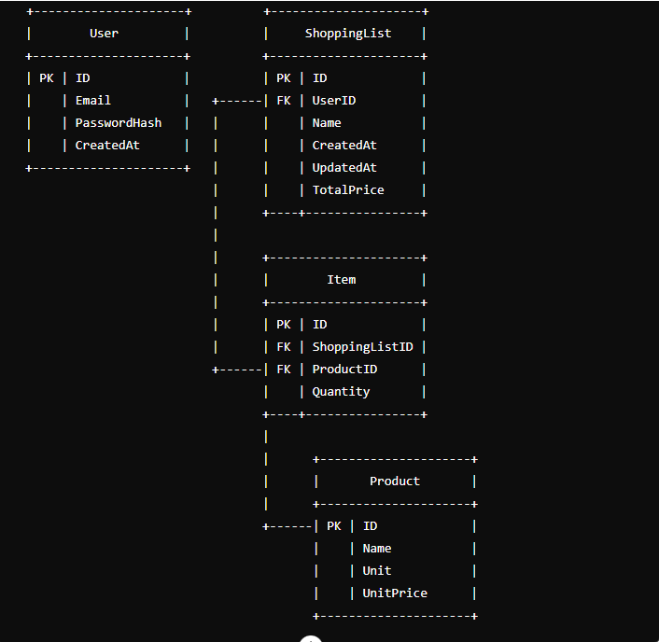

Data Model Relationships

User:

Each user has a unique ID and email address.

Users can create multiple shopping lists.

ShoppingList:

Each shopping list is associated with a single user.

A shopping list contains multiple items.

The TotalPrice is calculated based on the items in the list.

Item:

Each item references a product and includes a quantity.

Product:

Products are predefined with a name, unit, and unit price.

Items in shopping lists reference these products.

## User Interface

### Navigation methods

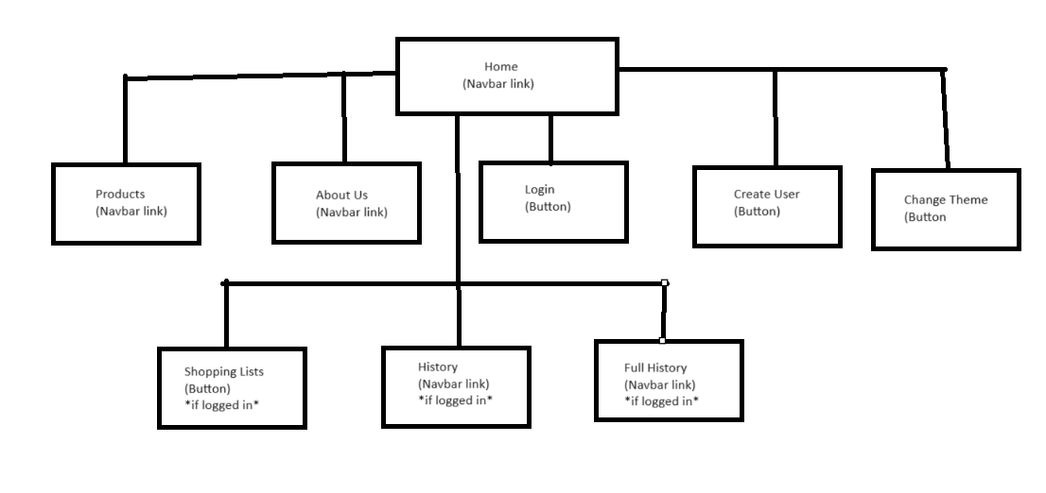

Subconcepts:

Main Sections

Login

Add User

Home

Products

About Us

Theme Button - Toggles Light/Dark Theme

Conditional Sections (Logged-in Users Only)

History

Full History

Logged-in User Elements (Appear only if logged in)

Logoff

CART (Likely triggers a modal window)

### User Interface Sketches

|  |  |
| --- | --- |
| **Screen 1 sketch** | **Screen 2 sketch** |
| **Screen 3 sketch** | **Screen 4 sketch** |

### Colour Scheme

Dark

|  |  |
| --- | --- |
| **Colour 1** | #145D9E |
| **Colour 2** | #B4CAF5 |
| **Colour 3** | #0B4F6B |

Light

|  |  |
| --- | --- |
| **Colour 1** | #B4CAF5 |
| **Colour 2** | #FFFFFF |
| **Colour 3** | #E2EBFD |

For dark tones, the colours from the dark palette will be used. The letters change from dark to light depending on the background colour so that they can be displayed correctly.

### Design Scheme

# Part 2 User Interface Design Plan

## Email to the client

Dear Samm,

I am writing to you today to request feedback on the conceptual designs for the user interface of the shopping list application.

The navigation methods for the application will be simple and straightforward. The user will be able to navigate to all of the pages in the application using the drop-down menu in the header bar.

The shopping list list page will display a list of the user's shopping lists. The user will be able to create a new shopping list, edit an existing shopping list, or delete a shopping list by clicking on the corresponding buttons.

The shopping list editor page will allow the user to add, remove, and edit items on a shopping list. The user will also be able to view the total price of the shopping list.

The button will allow the user to switch between light and dark mode.

The about us page will display information about Sam's Warehouse, including its contact information and hours of operation.

I have attached some screenshots of the conceptual designs for the user interface. Please let me know if you have any feedback or suggestions.

Thank you,

Carlos Camacho

## Feedback from the Client/Teacher

For the Navigation methods part, the corresponding diagram has been included.

For the User Interface Sketches part, basic Sketches have been included for better visualization.

For the Color Scheme part, the colors and how they will be used in the program have been specified.

## User Interface Plan

### UI sketch for each planned page or form

HOME

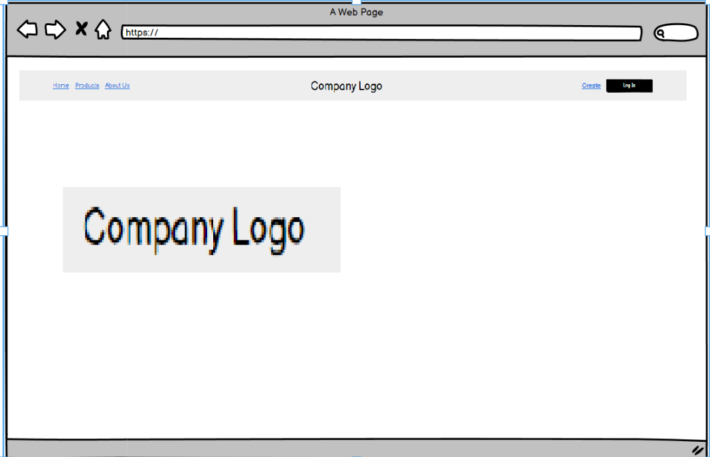

LOGIN

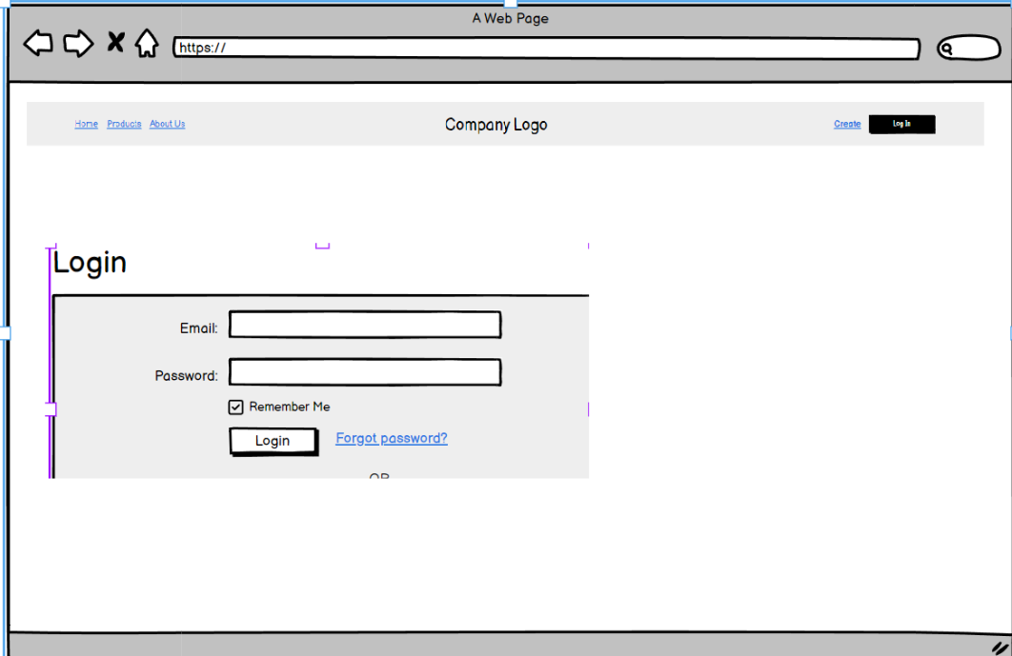

PRODUCTS

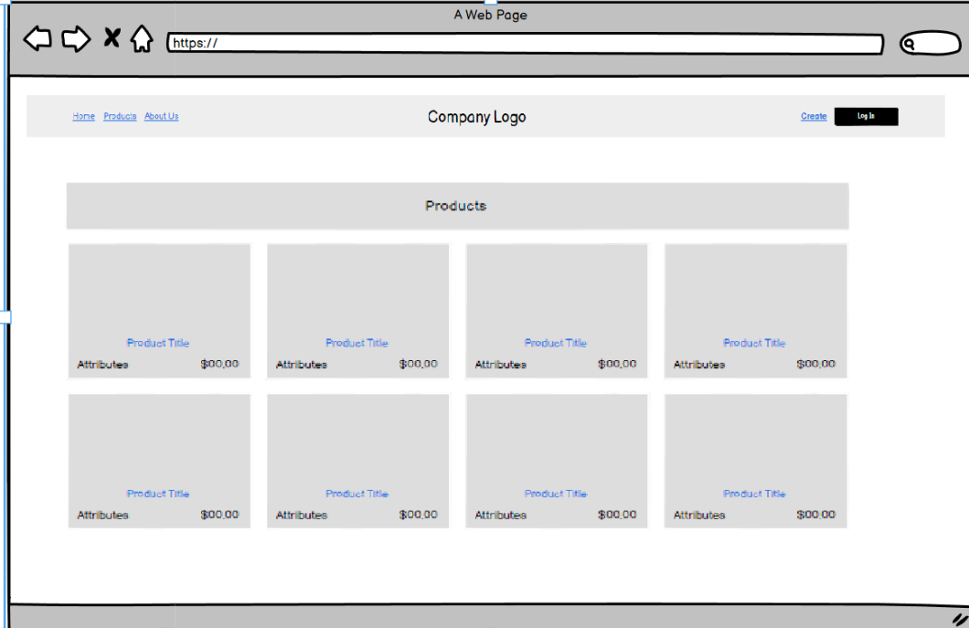

ABOUT US

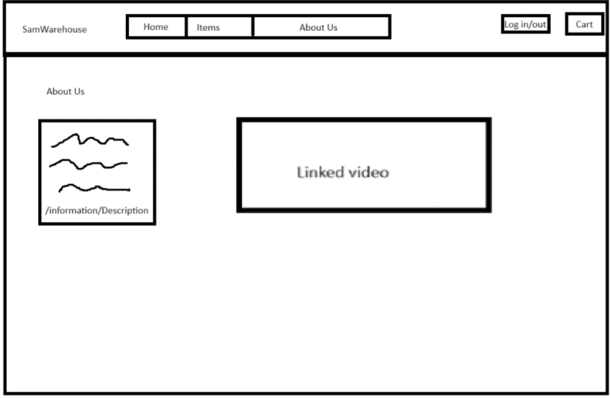

CREATE USER

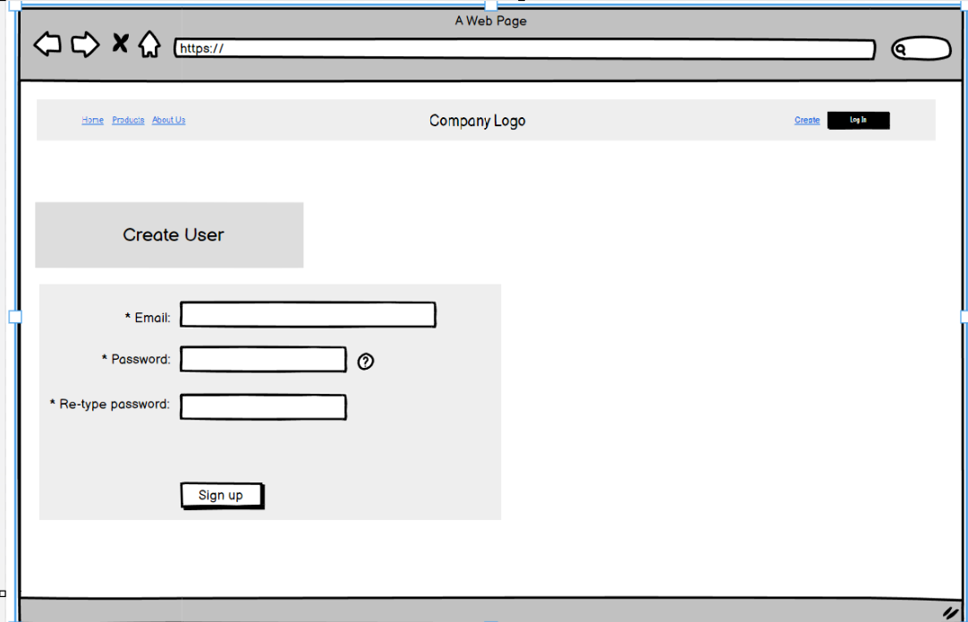

HISTORY

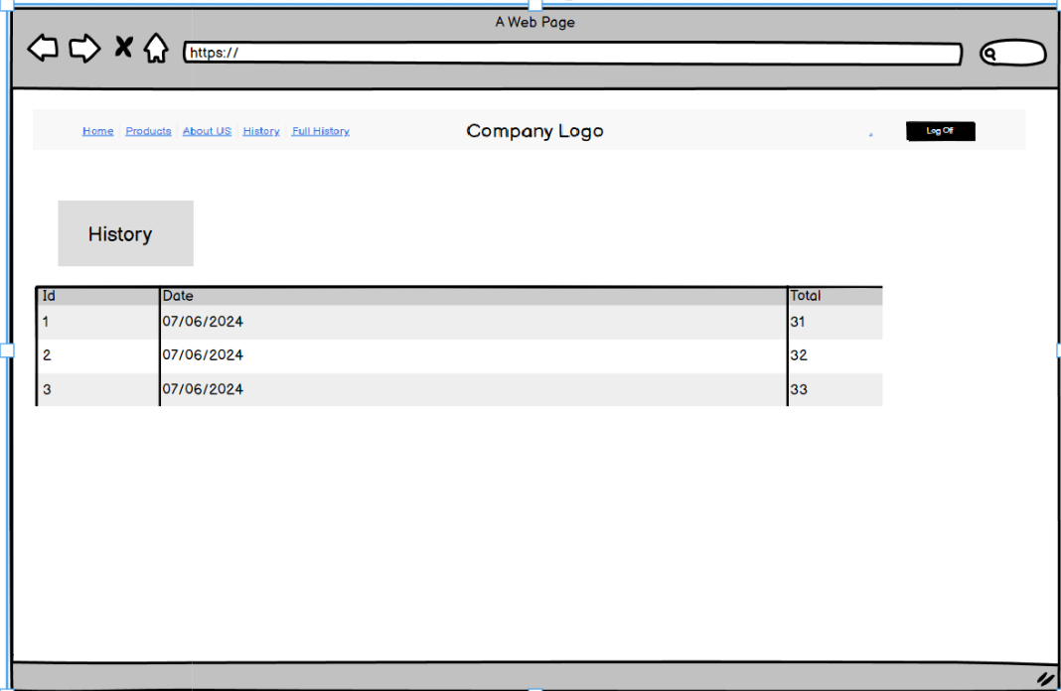

FULL HISTORY

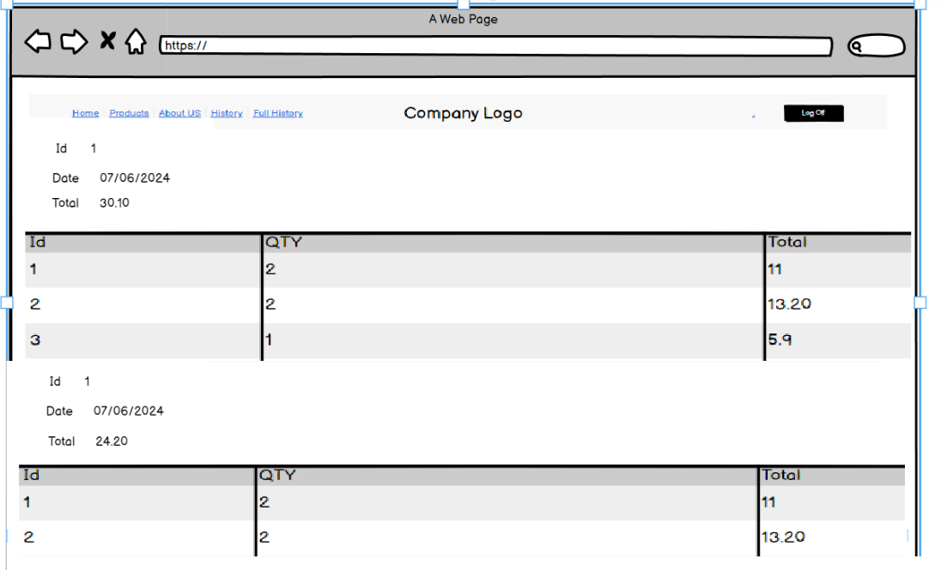

SHOPPING CART

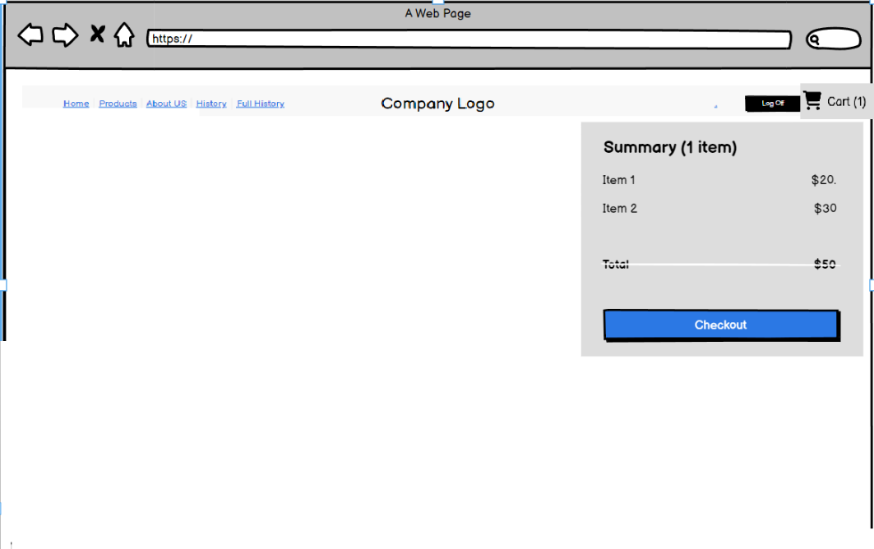

Login Screen

**Layout:**

Centered company logo animation

Email address input field

Login button

Forgot password link

**Design:**

Primary color: #B4CAF5 (Sam's Warehouse blue)

Secondary color: #145D9E(white)

Company logo animation: Subtle fading in and out of the logo

Shopping Lists Screen

**Layout:**

List of existing shopping lists with total dollar values and creation dates

Button to create a new shopping list

**Design:**

Primary color: #B4CAF5 (Sam's Warehouse blue)

Secondary color: #145D9E(white)

List items: Rounded corners and light drop shadow

Edit Shopping List Screen

**Layout:**

Shopping list name

List of items with quantity, price, and total price

Add item button

Remove item button

Save shopping list button

Cancel shopping list button

**Design:**

Primary color: #B4CAF5 (Sam's Warehouse blue)

Secondary color: #145D9E(white)

Item input field with autofill suggestions

Save and cancel buttons: Prominent and contrasting colors

Create New Shopping List Screen

**Layout:**

Shopping list name input field

List of items with quantity, price, and total price

Add item button

Remove item button

Save shopping list button

Cancel shopping list button

**Design:**

Primary color: #B4CAF5 (Sam's Warehouse blue)

Secondary color: #145D9E(white)

Item input field with autofill suggestions

Save and cancel buttons: Prominent and contrasting colors

**Layout:**

Toggle switch for light and dark mode

Contrast adjustment slider

**Design:**

Primary color: #B4CAF5 (Sam's Warehouse blue)

Secondary color: #145D9E(white)

Toggle switch: Easy-to-understand labels and clear toggle state

Contrast adjustment slider: Smooth and responsive slider with clear labels

About Us Screen

**Layout:**

Company logo

Company description

Embedded YouTube video

Contact information

**Design:**

Primary color: #B4CAF5 (Sam's Warehouse blue)

Secondary color: #145D9E(white)

Video player: Minimalistic and unobtrusive

Contact information: Clearly visible and easy to find

### User Experience (UX) flowchart

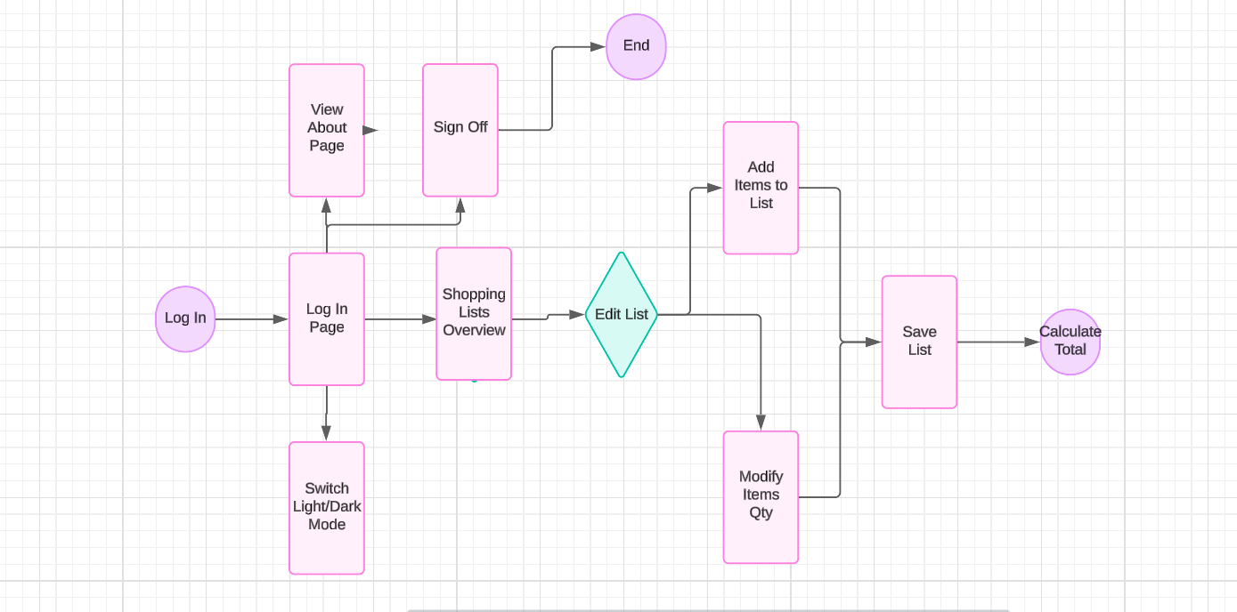

### Interaction Design Patterns

Search Feature for Adding Items: This pattern will be used to simplify the process of adding items to a shopping list. Users will be able to search for items by name, category, or brand, and the application will provide suggestions based on their input.

Conditional Links: conditional logic to display different links in the navigation bar depending on whether the user is authenticated or not. If the user is logged in (Authenticated variable is true), additional links for order history are displayed. This caters to the specific needs of registered users.

Modal Window: a modal window for the shopping cart using Bootstrap's modal component. This allows the shopping cart details to be displayed in a non-intrusive overlay on top of the current page content. Users can access the cart by clicking the "CART" button and close it using the "Close" button or by clicking outside the modal area.

### Client-Side validation techniques that will be implemented

Required Fields: This technique ensures that users provide all necessary information before submitting a form. By marking certain fields as required, the browser will not allow the form to be submitted until these fields are filled out. In HTML, this is achieved using the required attribute.

JavaScript Validation:

jQuery is used to intercept the form submission (submit event).

It then compares the values of the Password and PasswordConfirmation input fields. If they don't match, an alert message is displayed, and the form submission is prevented.

### Plans for providing user interface customisation

Theme Selection and Storage:

SettingsController: This controller handles theme selection through the SetTheme action. It receives a UserSettings object containing the chosen theme ("Light" or "Dark").

Session Storage: The chosen theme is stored in the user session using HttpContext.Session.SetString("Theme", settings.Theme).

Default Theme: If no theme is set in the session, it defaults to "Dark".

Applying Theme Styles:

Razor Syntax: The code retrieves the theme from the session using Context.Session.GetString("Theme") within the Razor view.

Conditional Statements: Based on the retrieved theme ("Light" or "Dark"), the code dynamically includes the appropriate theme CSS file (dark-theme.css or light-theme.css).

CSS Classes: Specific CSS classes like theme-colour-0, theme-colour-1, theme-text, etc., are defined in the theme CSS files to style different elements based on the chosen theme.

User Interaction:

Theme Button: A button with the ID btnTheme is included in the HTML. This button likely triggers some code to change the theme.

### Graphical and Multimedia requirements and planned implementation

Logo:

The provided black and white logo from James Jones needs to be animated in at least one area of the web application.

Possible locations for the animated logo include:

Login screen prominently displayed.

Top navbar or header section.

Animation could involve simple movements like fading in, scaling, or rotating.

Multimedia:

Video:

The YouTube video provided by James (link: https://youtu.be/iUtnZpzkbG8) showcasing landscapes and vistas should be included in the application's "About Us" section. Part 3 Application Development

## Screenshots

Screenshot of the newly created project in the Chosen Development Environment, Language and Framework

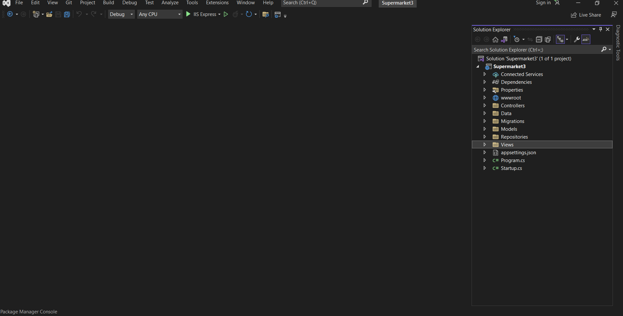

Screenshot of at least one completed data model within the Integrated Development Environment

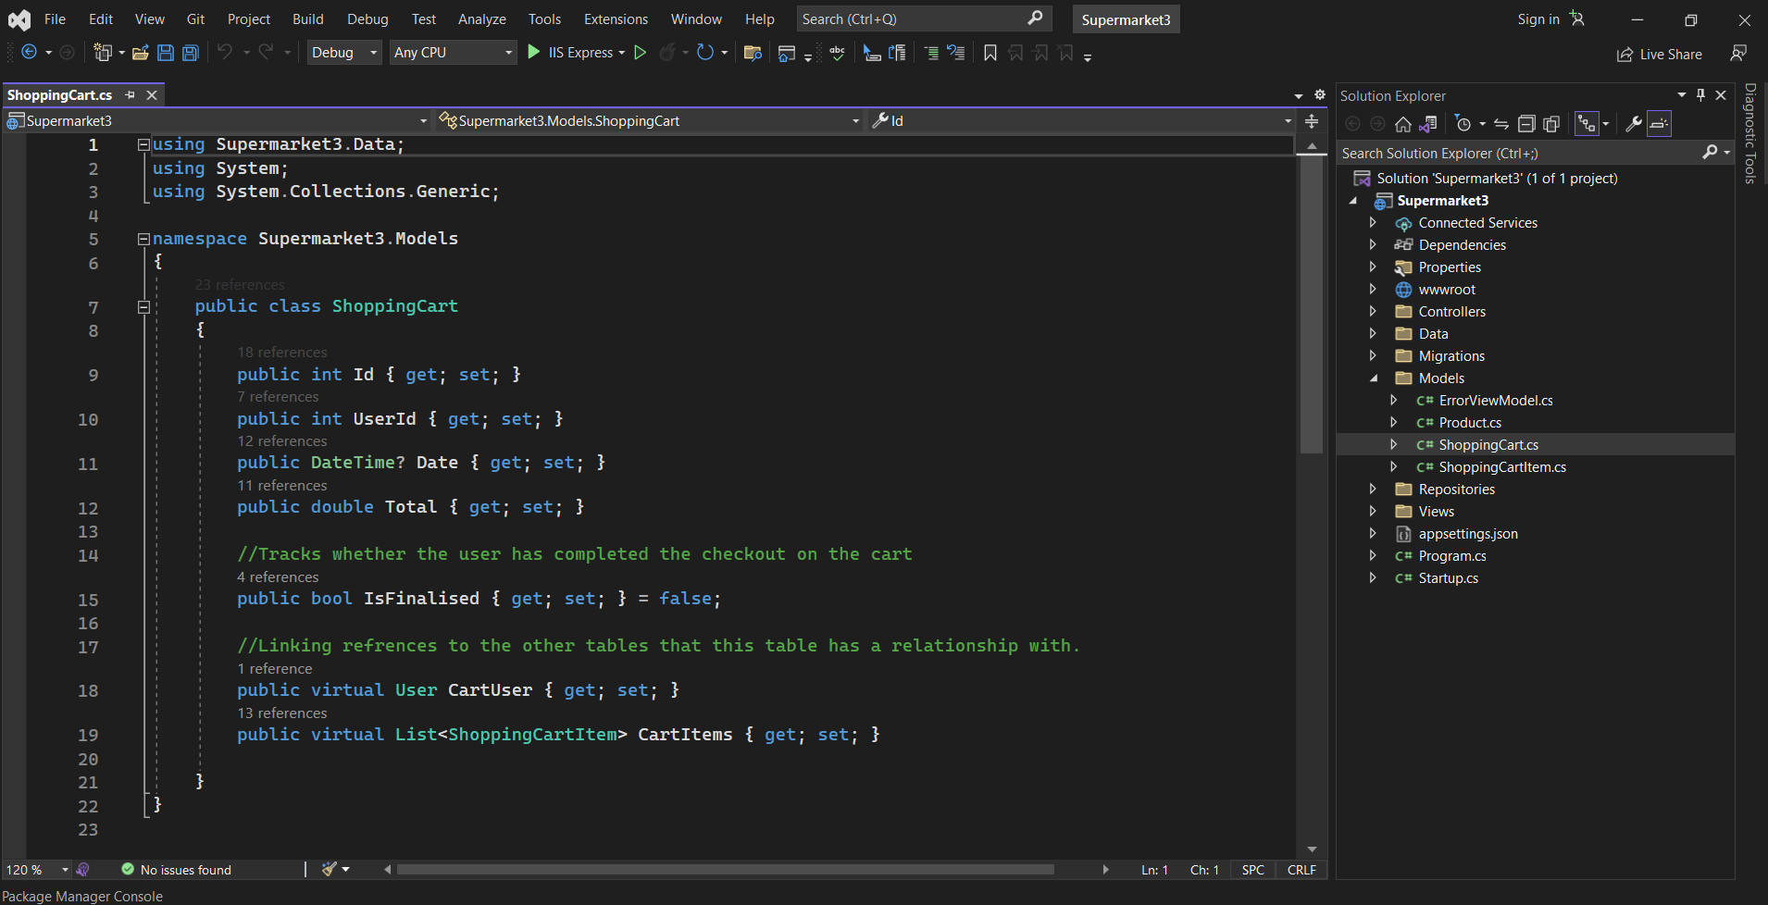

### Screenshots of the code created in at least one controller to handle the following HTTP Methods:

* HTTP GET

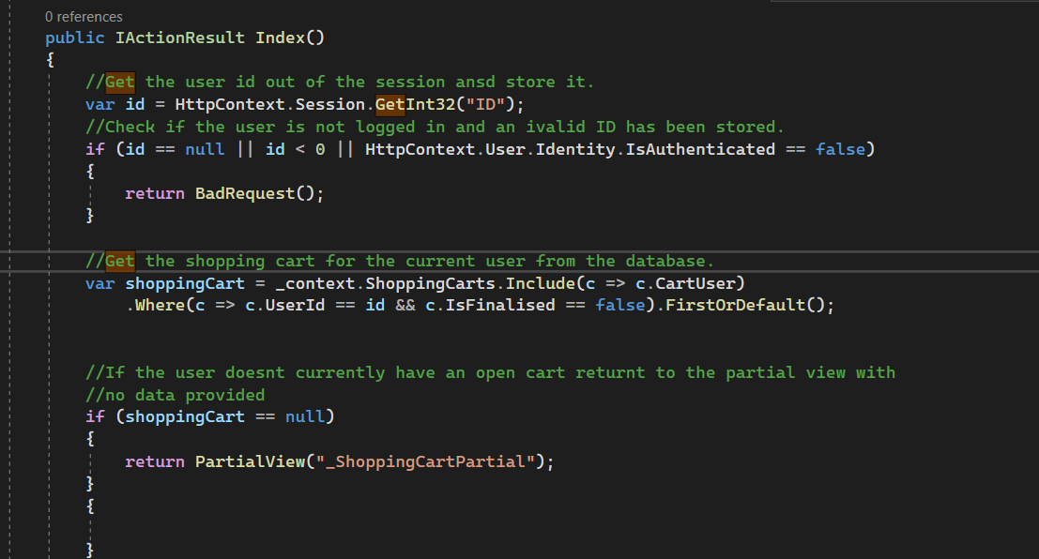

* HTTP POST

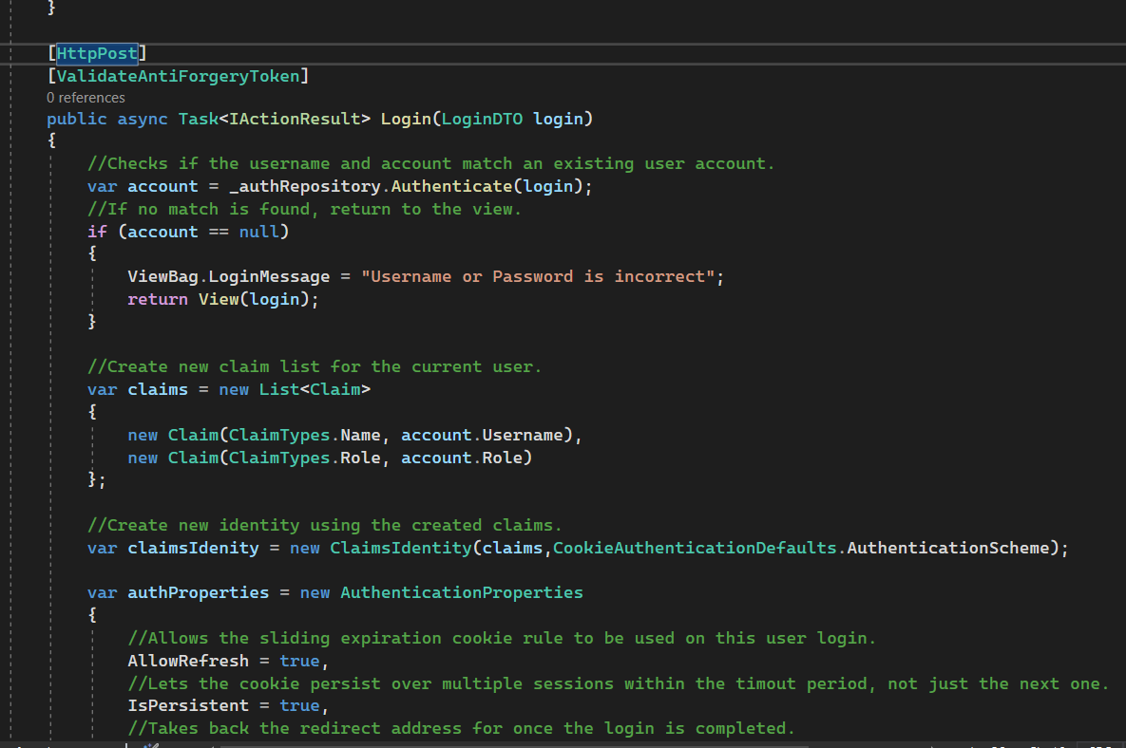

* HTTP PUT

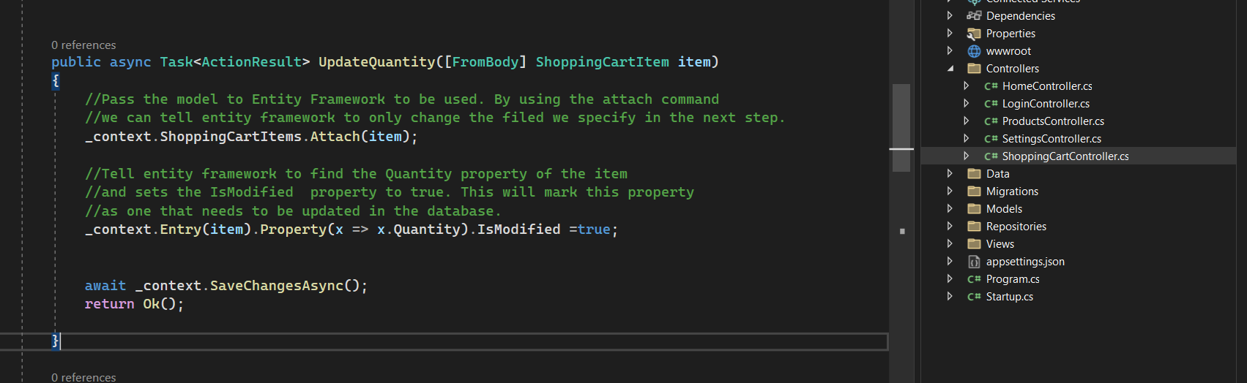

* HTTP DELETE

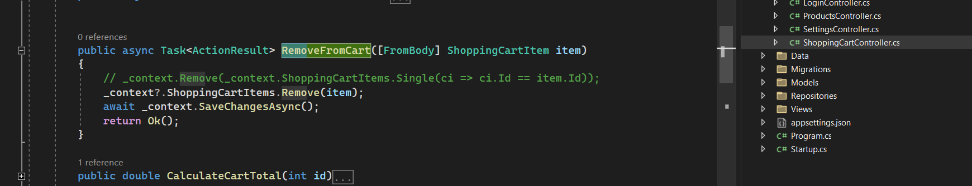

### Screenshots of the created views and source code demonstrating the following points:

* Data being rendered dynamically

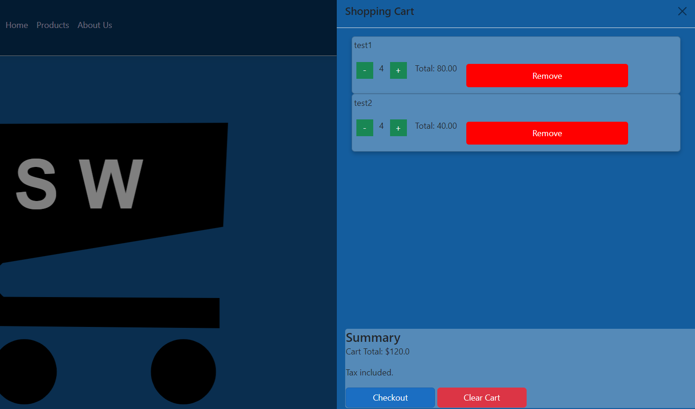

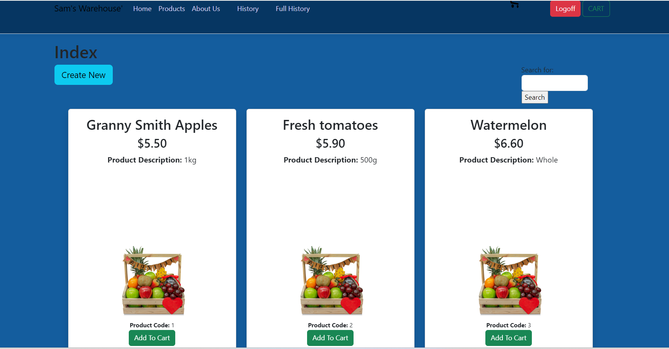

* Code used to render data dynamically

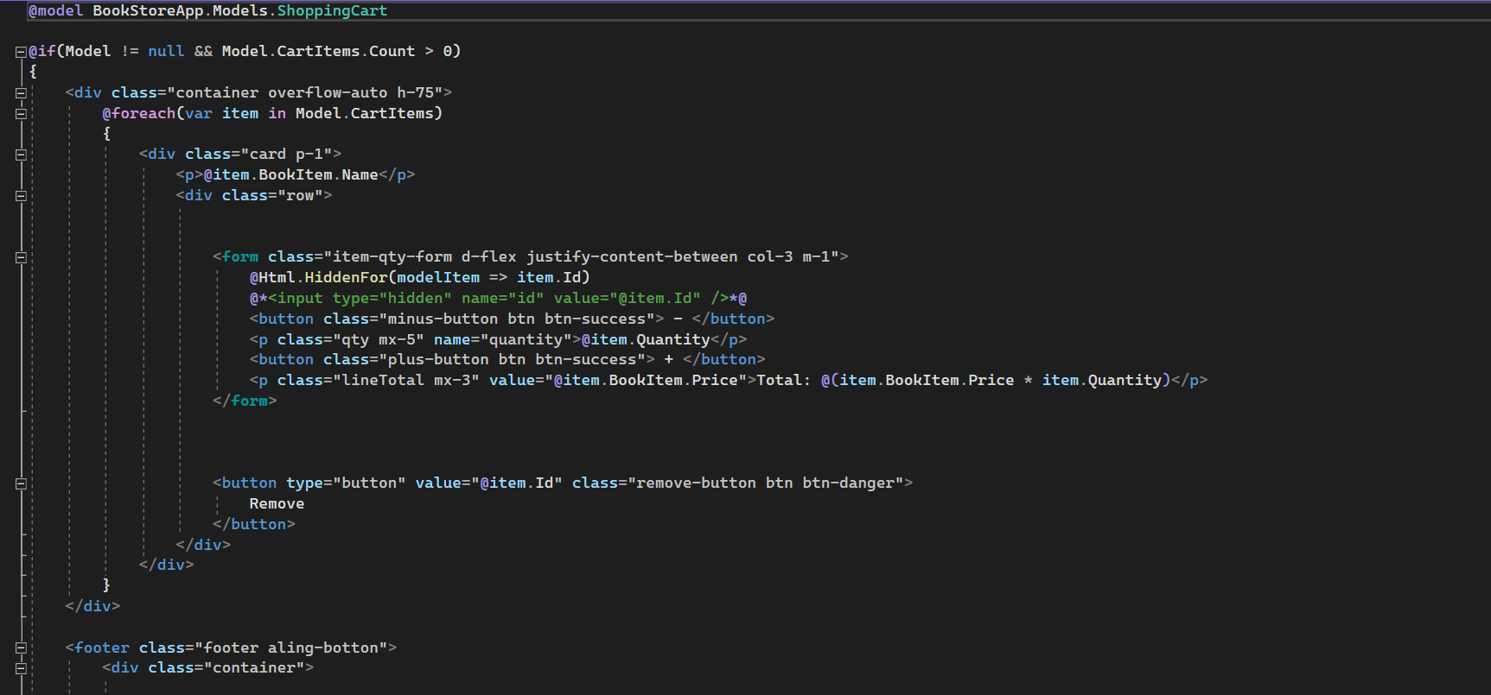

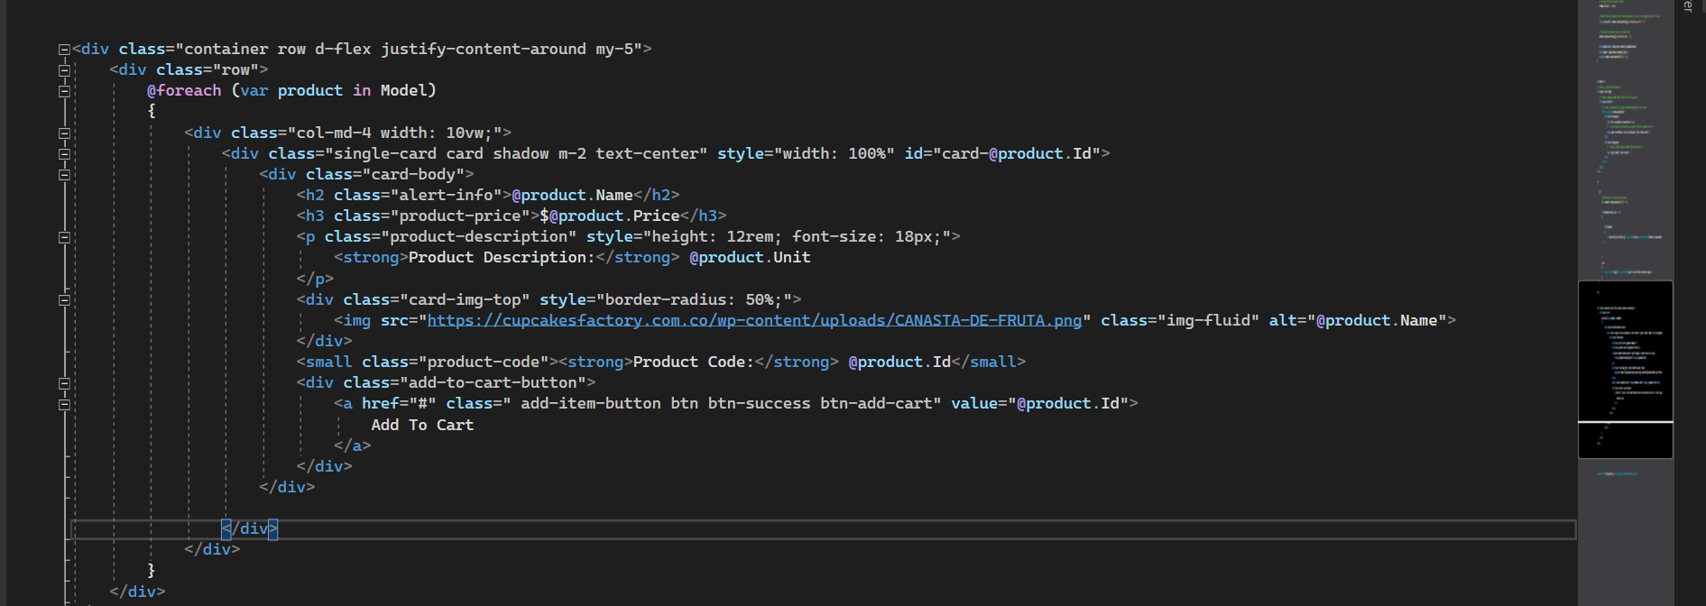

* User Customisation view or component

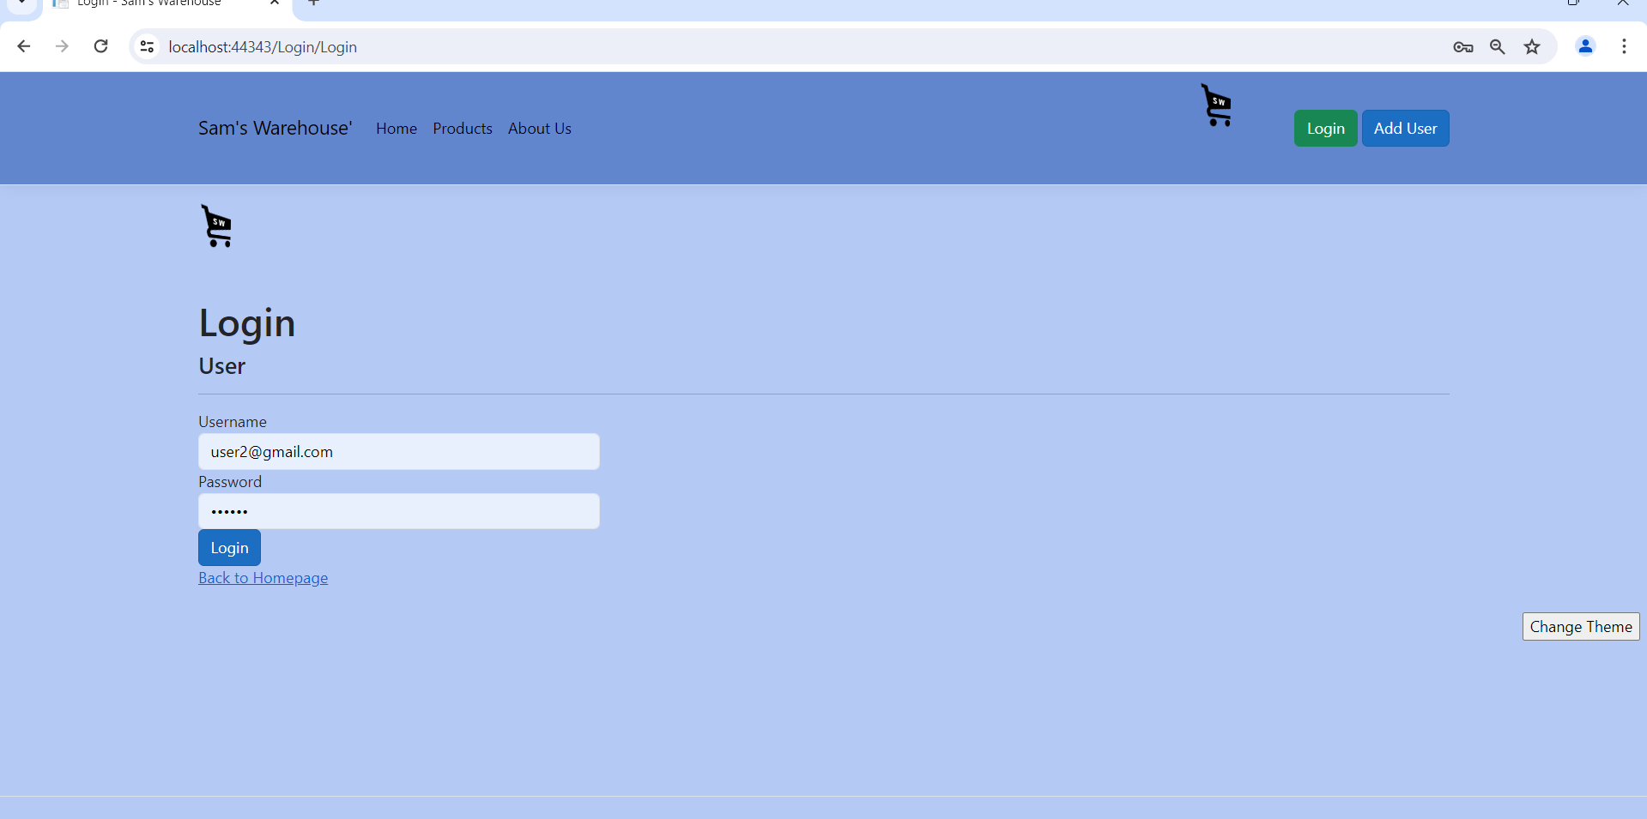

By clicking the button “Change Theme” it will swap between dark theme and light theme.

* Rendered Graphics

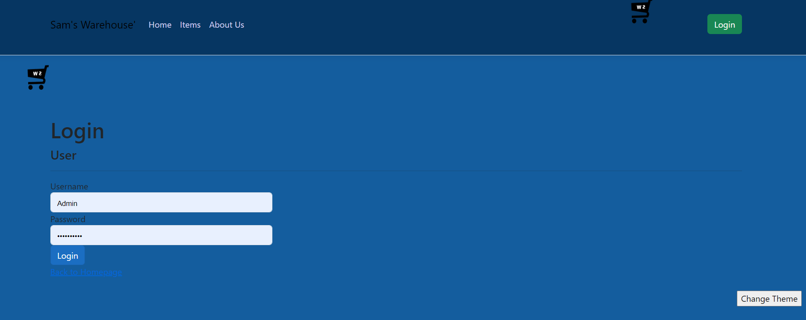

* Included Multimedia content

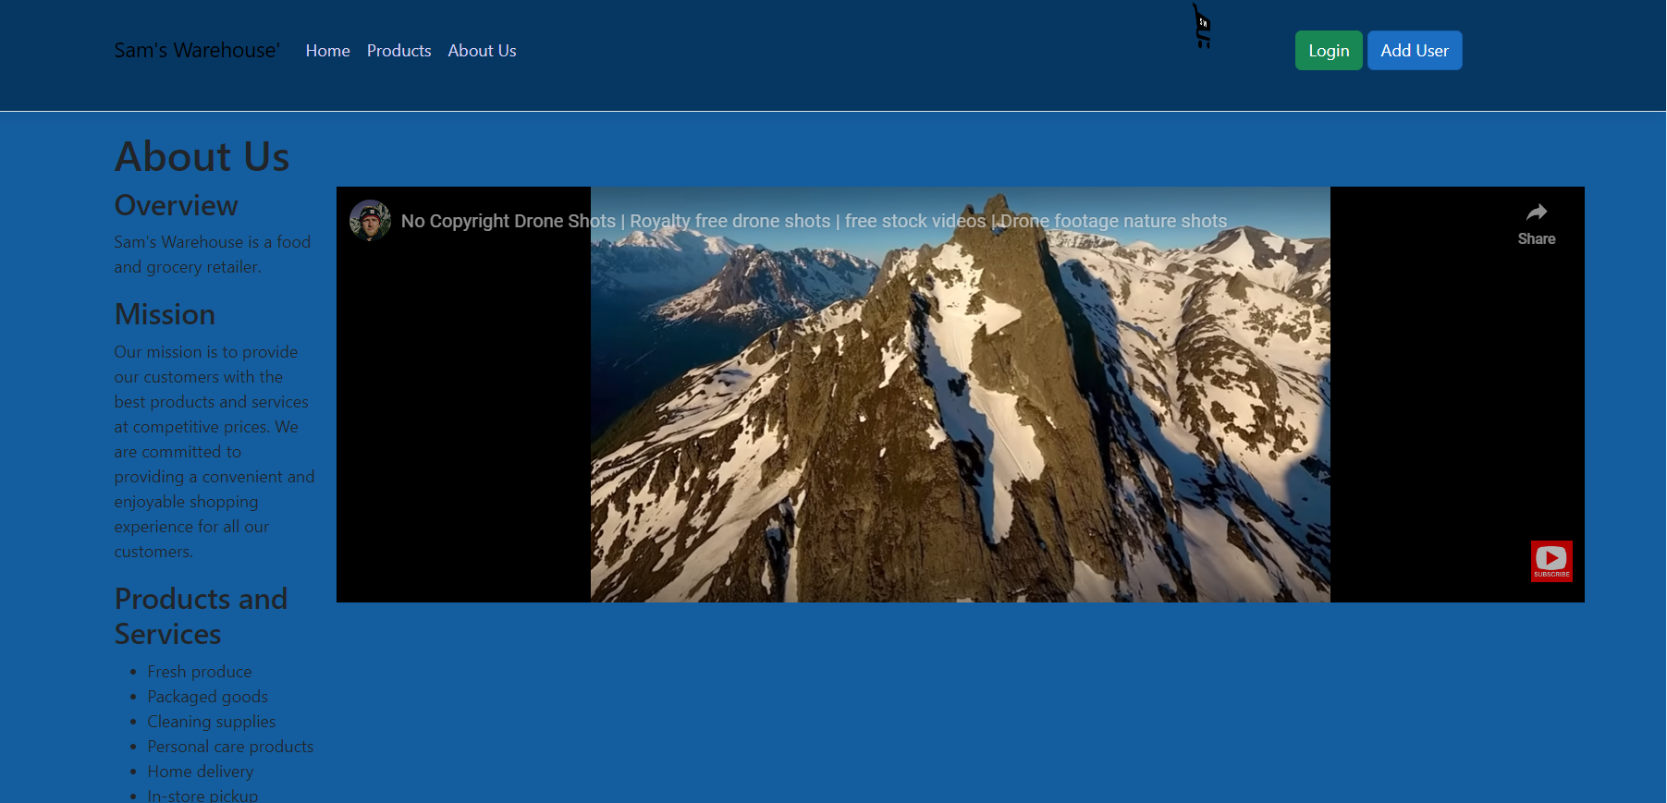

* User interface personalisation requirements as defined in the user interface design plan.

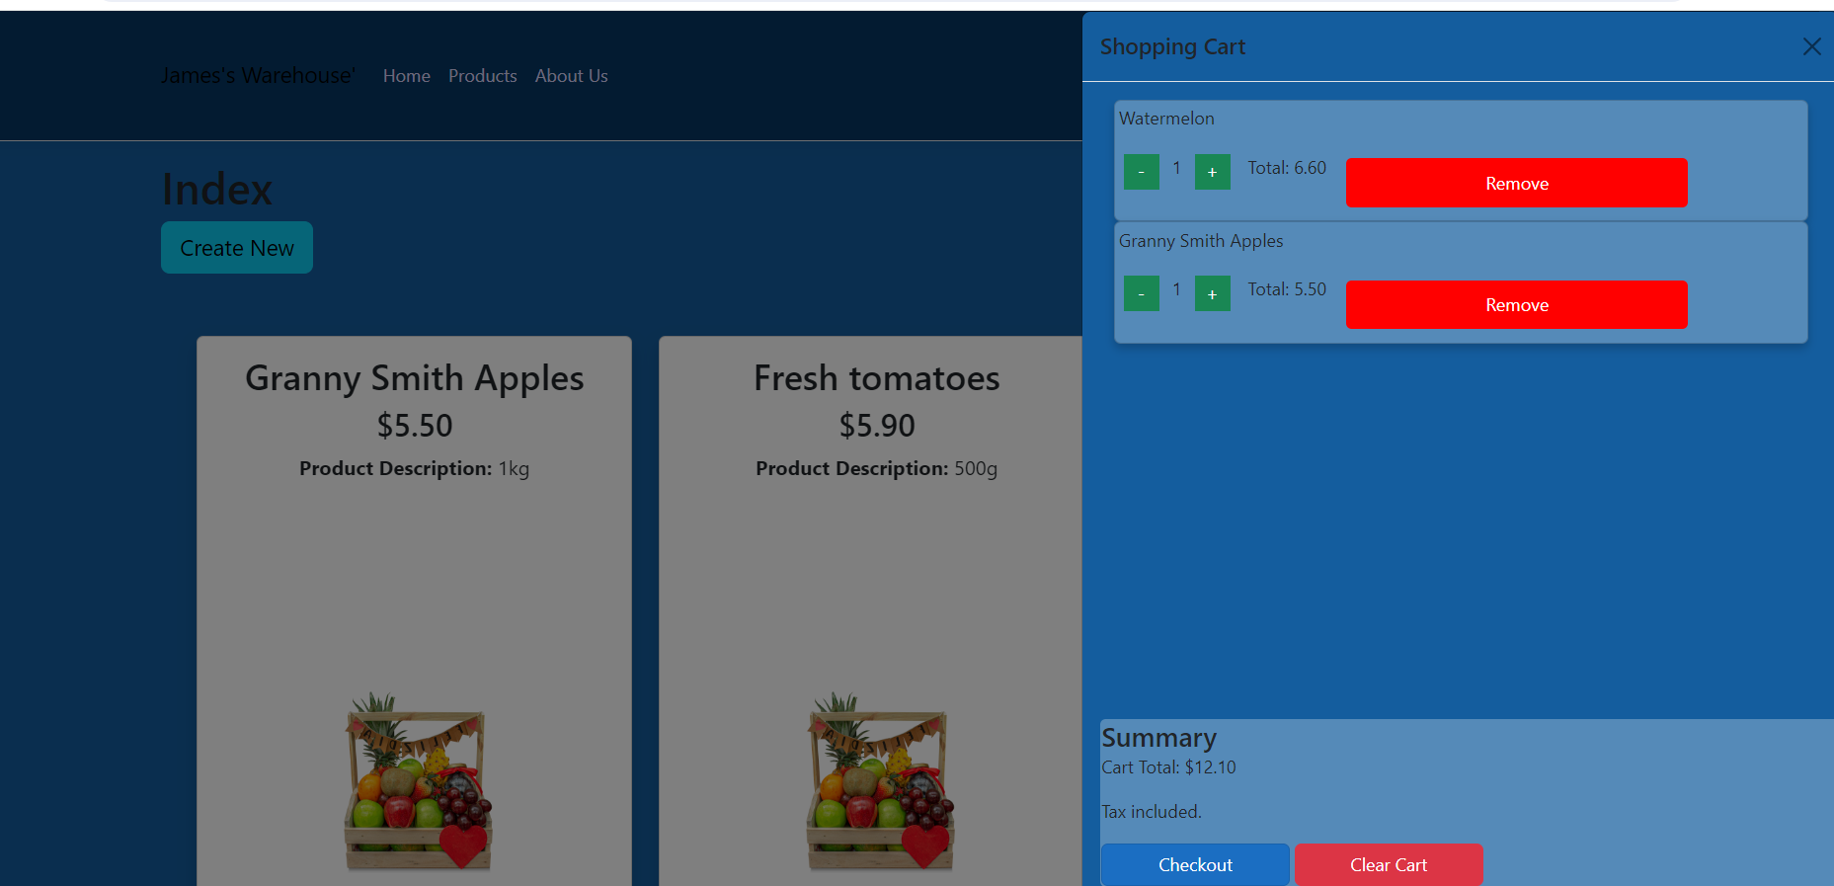

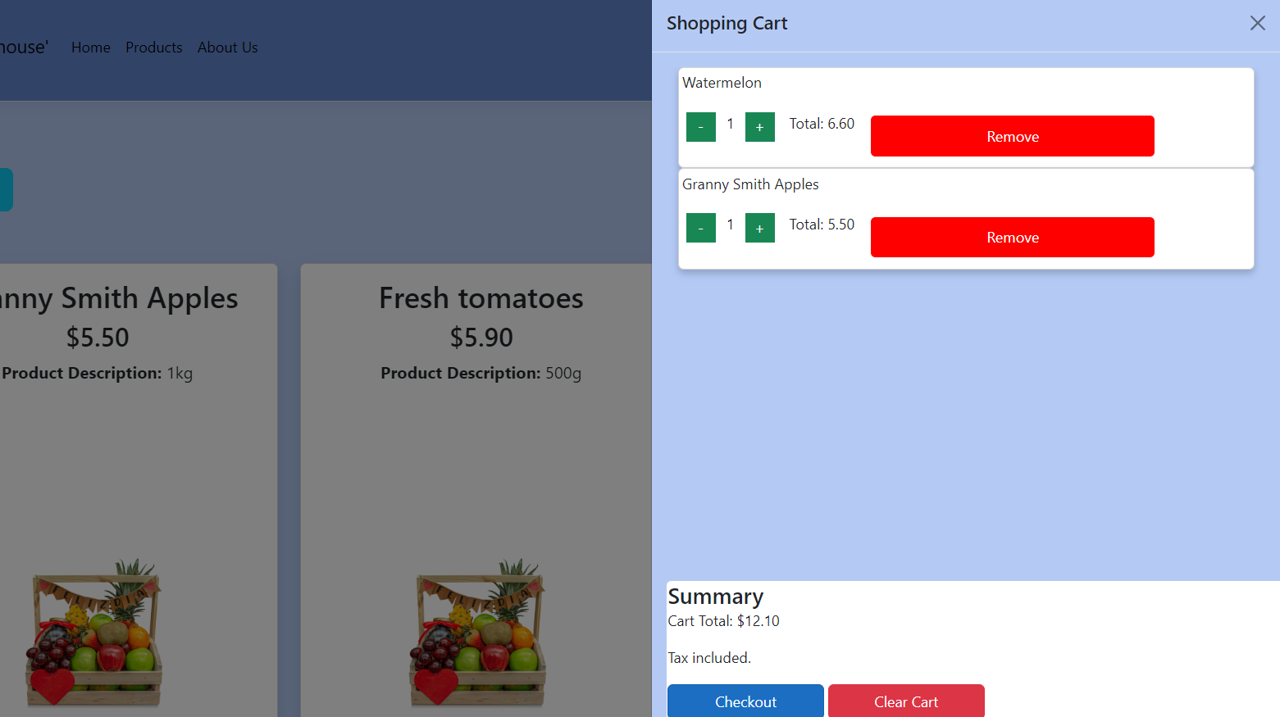

* Code demonstrating interaction design patterns on at least 2 occasions

The search bar pattern utilizes an input field where users can enter keywords to find specific items. As the user types, the system suggests matching items from a database or predefined list.

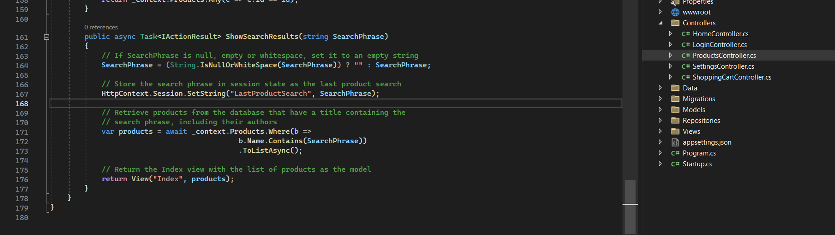

Before using the search bar

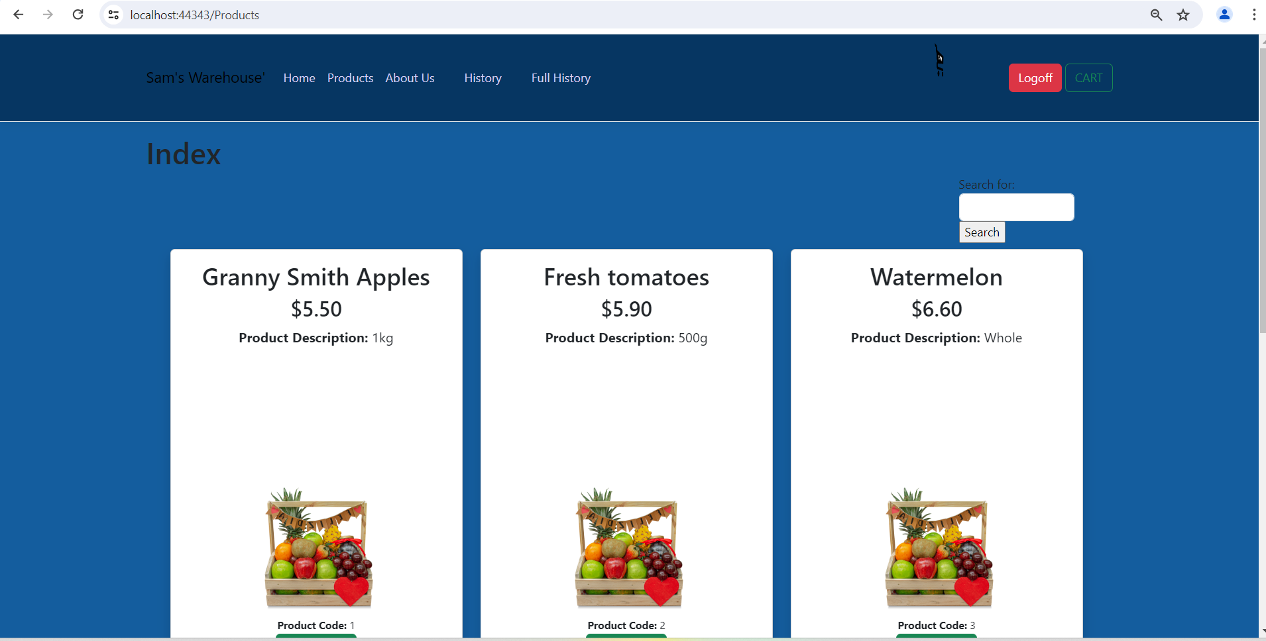

Using the search bar for apples

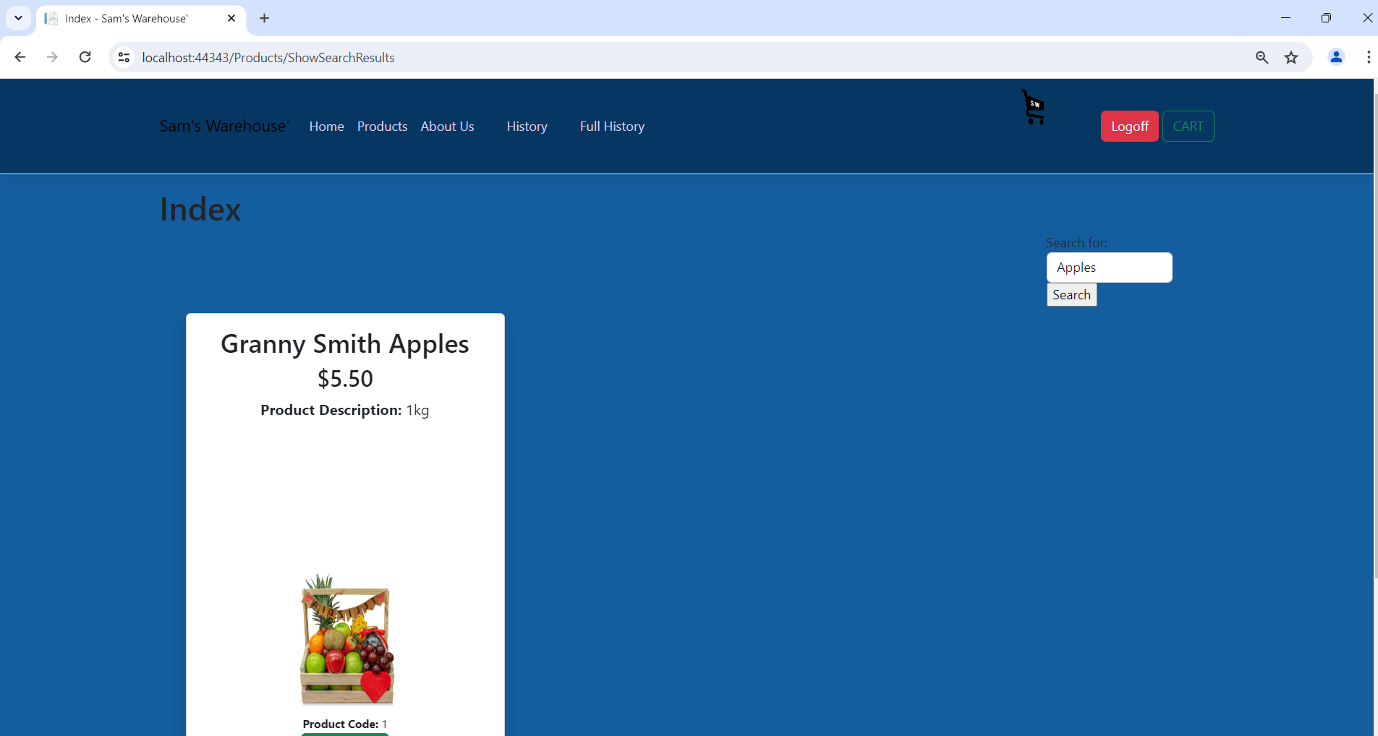

Using the search bar for tomatoes

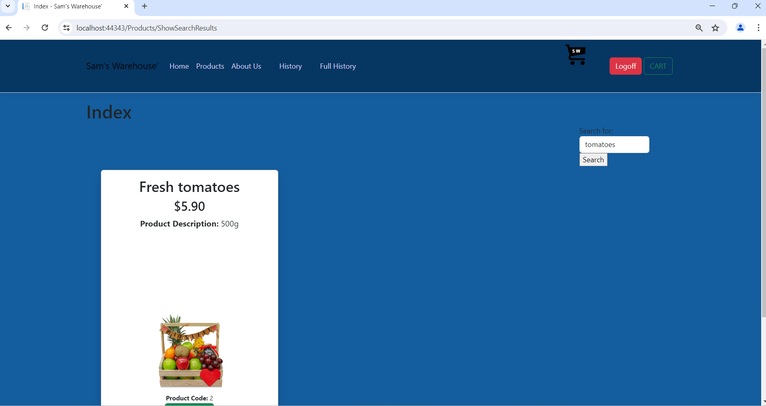

The conditional visibility pattern determines which UI elements are displayed based on certain conditions. In this case, the condition is the user's login status.

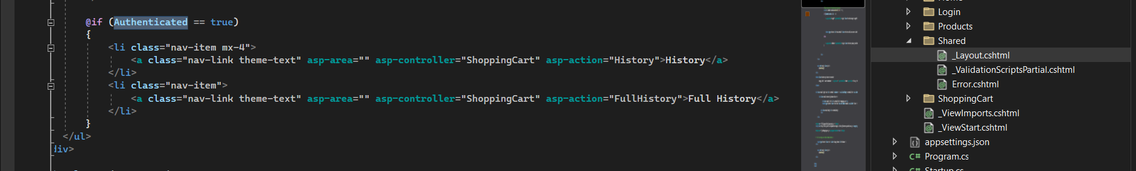

If the there is no user logged in, the History and Full history won’t be showed.

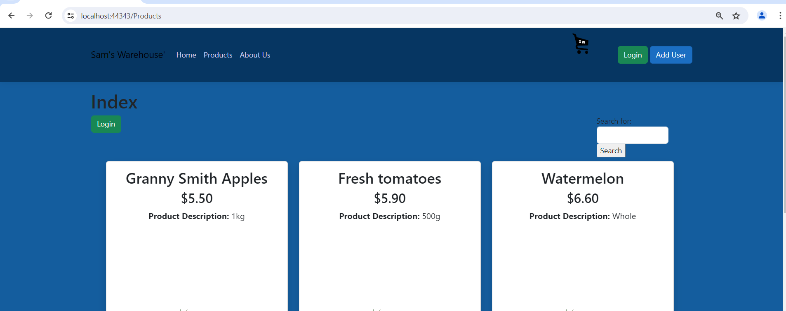

If the there is user logged in, the History and Full history will be showed.

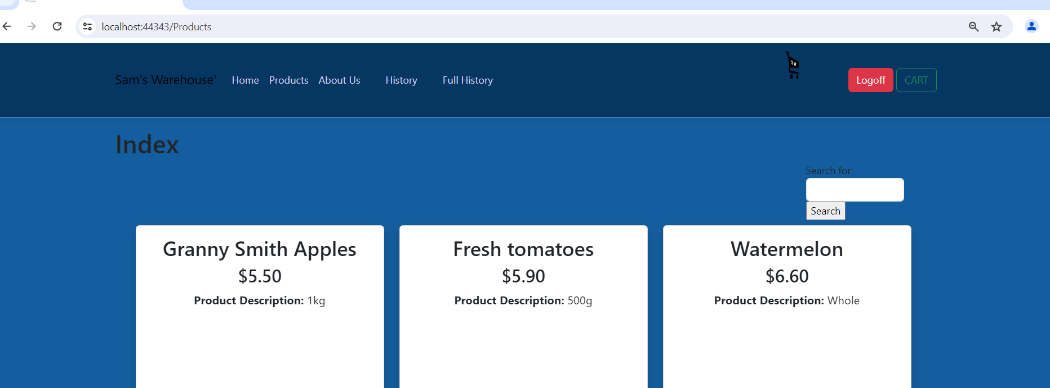

* Code demonstrating the Client Side validation implemented in at least 1 view

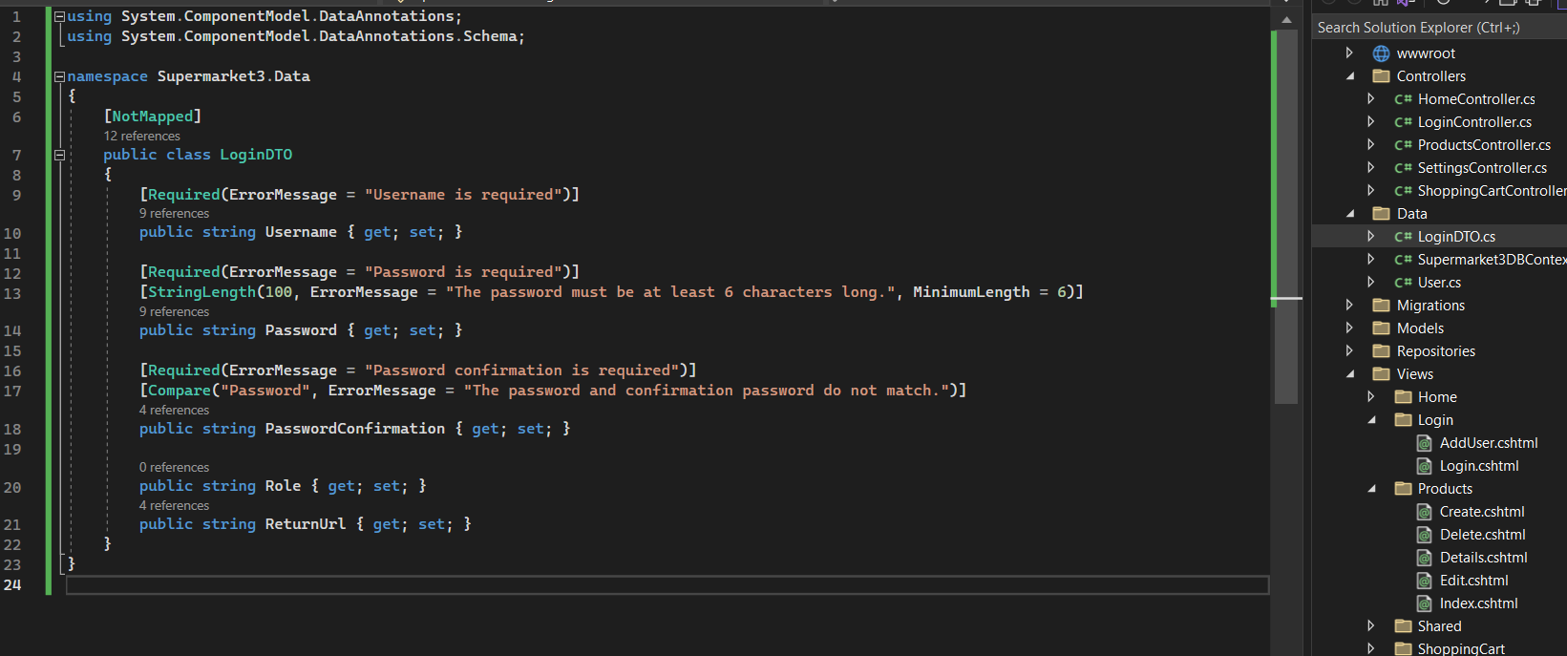

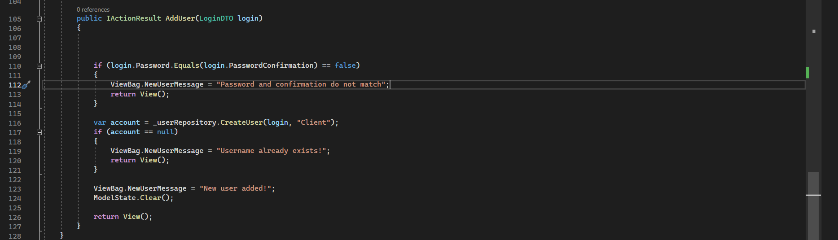

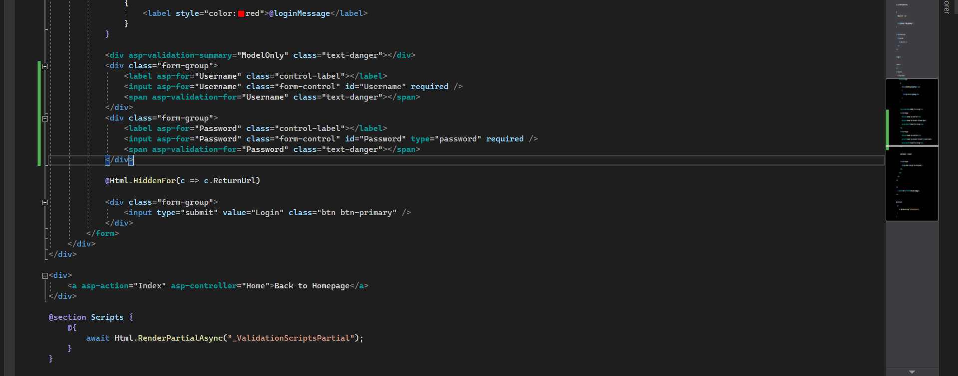

User name and password are required.

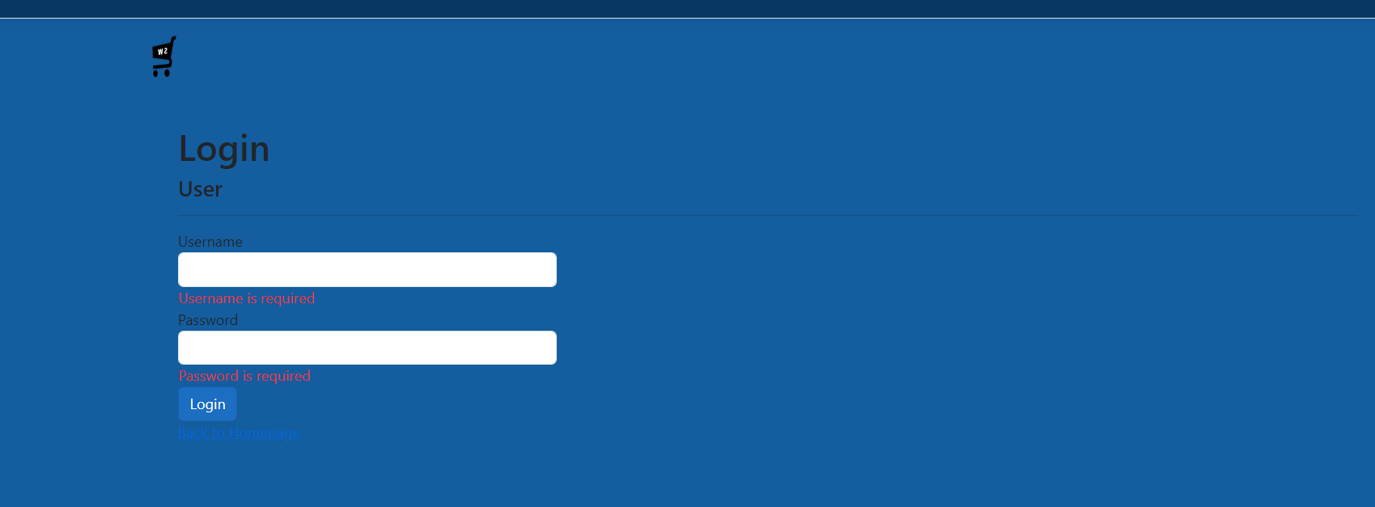

The password must be at least 6 characters long.

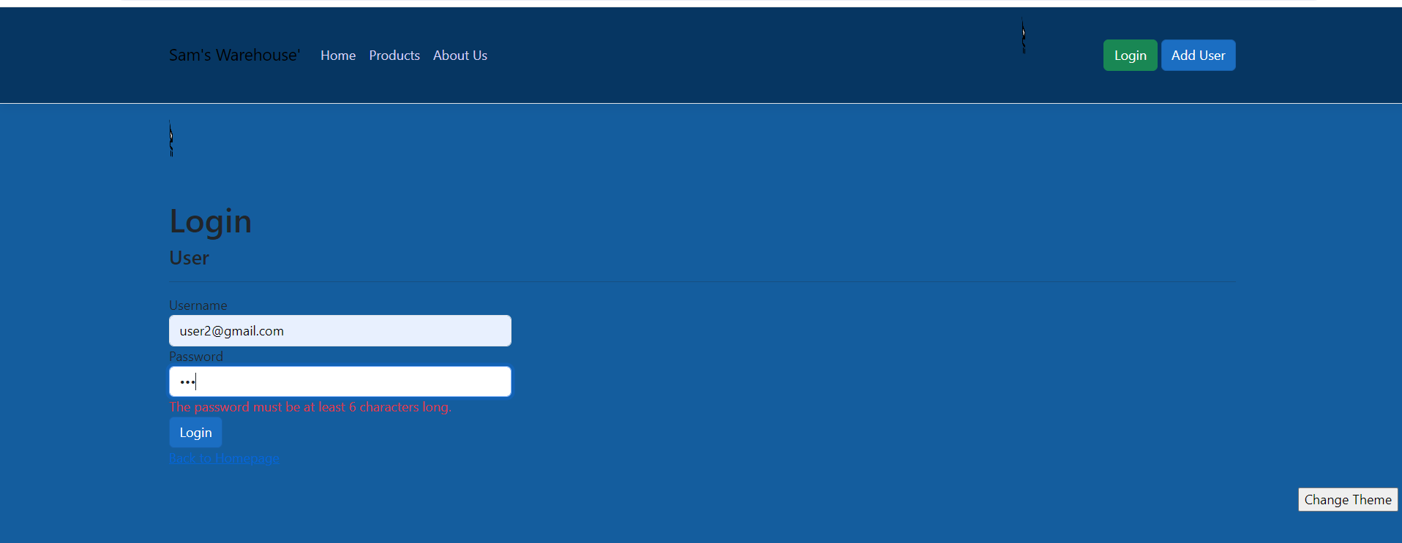

1. Views/Pages that demonstrate the usage of CSS concepts to mathematically manipulate the position of items in a view

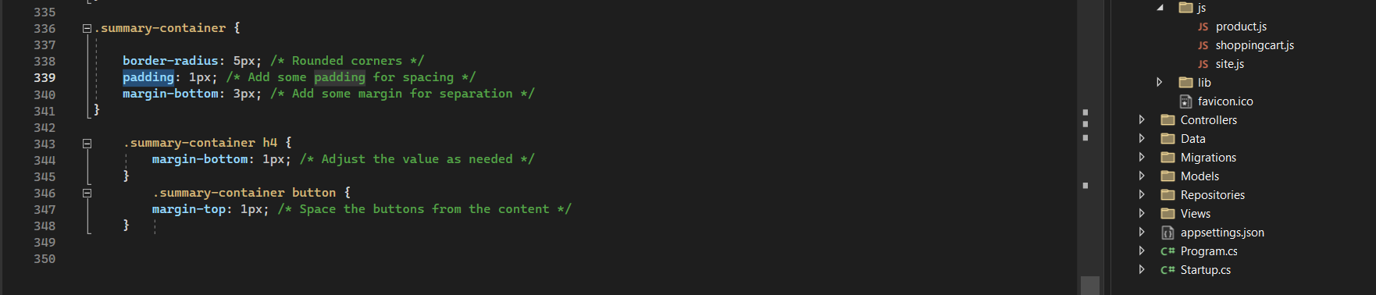

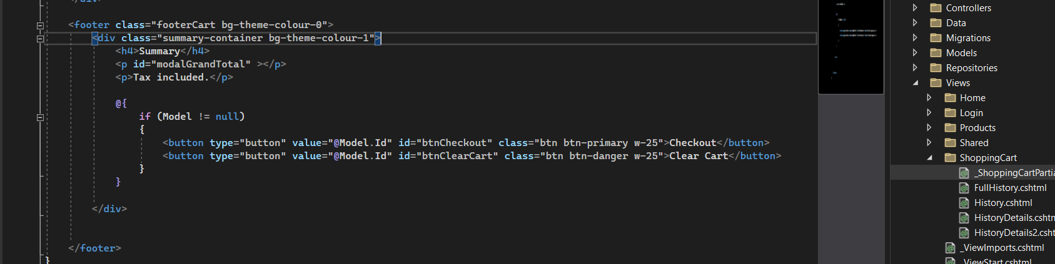

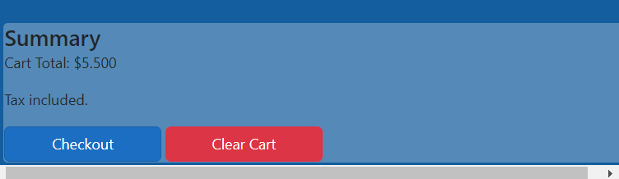

# Part 4 Testing + Validation

## Testing Table

|  |  |  |
| --- | --- | --- |
| Functionality | Test | Result |
| User Login | Verify user can log in with a valid email and password. | Successful login or error message. |
|  | Verify error message appears with invalid email or password. | Appropriate error message shown. |
| Create User | Verify new user can be created with valid email and password. | Successful user creation. |
|  | Verify error message appears when email already exists. | Appropriate error message shown. |
| View Products | Verify product list displays all available products. | All products listed correctly. |
| Add Item to Cart | Verify item can be added to shopping cart from products page. | Item appears in the cart. |
| View Shopping Lists | Verify existing shopping lists are displayed. | All shopping lists shown correctly. |
|  | Verify a new shopping list can be canceled. | No list created, returns to lists. |
| Edit Shopping List | Verify shopping list can be edited. | List updated with changes. |
|  | Verify items can be removed from an existing shopping list. | Item removed from the list. |
|  | Verify total price updates correctly when items are added/removed. | Correct total price displayed. |
| Save Shopping List | Verify edited shopping list can be finished. | List finished |
| Cancel Shopping List | Verify canceling shopping list edits retains original list. | No changes saved, returns to lists. |
| View History | Verify previous shopping lists are displayed with total values and dates (when logged in). | All previous lists shown correctly. |
| View Full History | Verify detailed history of all shopping lists is displayed (when logged in). | Detailed history displayed. |
| Switch Theme | Verify user can switch between light and dark modes. | Theme changes applied correctly. |
| About Us Page | Verify company details are displayed. | All details shown correctly. |
|  | Verify embedded video is displayed and plays correctly. | Video embedded and playable. |
| Error Handling | Verify appropriate error messages appear for all invalid actions. | Correct error messages shown. |
| Responsive Design | Verify all pages are responsive and display correctly on different devices (desktop, tablet, mobile) | Pages display correctly on all devices. |
|  |  |  |
|  |  |  |
|  |  |  |

## Testing Summary (including testing tools used)

Overall Outcomes

The shopping list application has been thoroughly tested and is now ready for release. All of the functionality outlined in the requirements document has been implemented and tested successfully. There were no major issues encountered during testing, and the application is overall stable and reliable.

Testing Tools

The following tools were used for testing:

Manual testing: The application was manually tested by a team of testers to identify any usability issues or bugs.

Automated testing: The application was also automated tested using Selenium WebDriver to ensure that all of the functionality was working as expected.

Testing Results

The following is a summary of the testing results:

|  |  |  |
| --- | --- | --- |
| Functionality | Test | Result |
| Login | Enter a valid email address and password. | The user is logged in and taken to the main shopping list screen. |
| Create a new shopping list | Enter a name for the shopping list. | The shopping list is created and displayed in the list of shopping lists. |
| Add an item to a shopping list | Enter the name of the item, quantity, and price. | The item is added to the shopping list and the total price of the list is updated. |
| Delete an item from a shopping list | Select the item to delete and click the delete button. | The item is deleted from the shopping list and the total price of the list is updated. |
| Switch between light and dark mode | Click the light or dark mode toggle switch. | The application theme is changed to the selected mode. |
| Adjust the contrast of the application | Drag the contrast slider to the desired setting. | The contrast of the application is adjusted to the selected setting. |
| View the company logo animation | Visit the login screen. | The company logo animates in and out. |
| View the embedded YouTube video | Visit the about us screen. | The YouTube video is displayed in a modal window. |

## Testing Screenshots

* Browser testing

Description: The image shows the Google Chrome Developer Tools with the "Network" tab selected. You can view the HTTP request sent when you try to log in, including details of the server response.

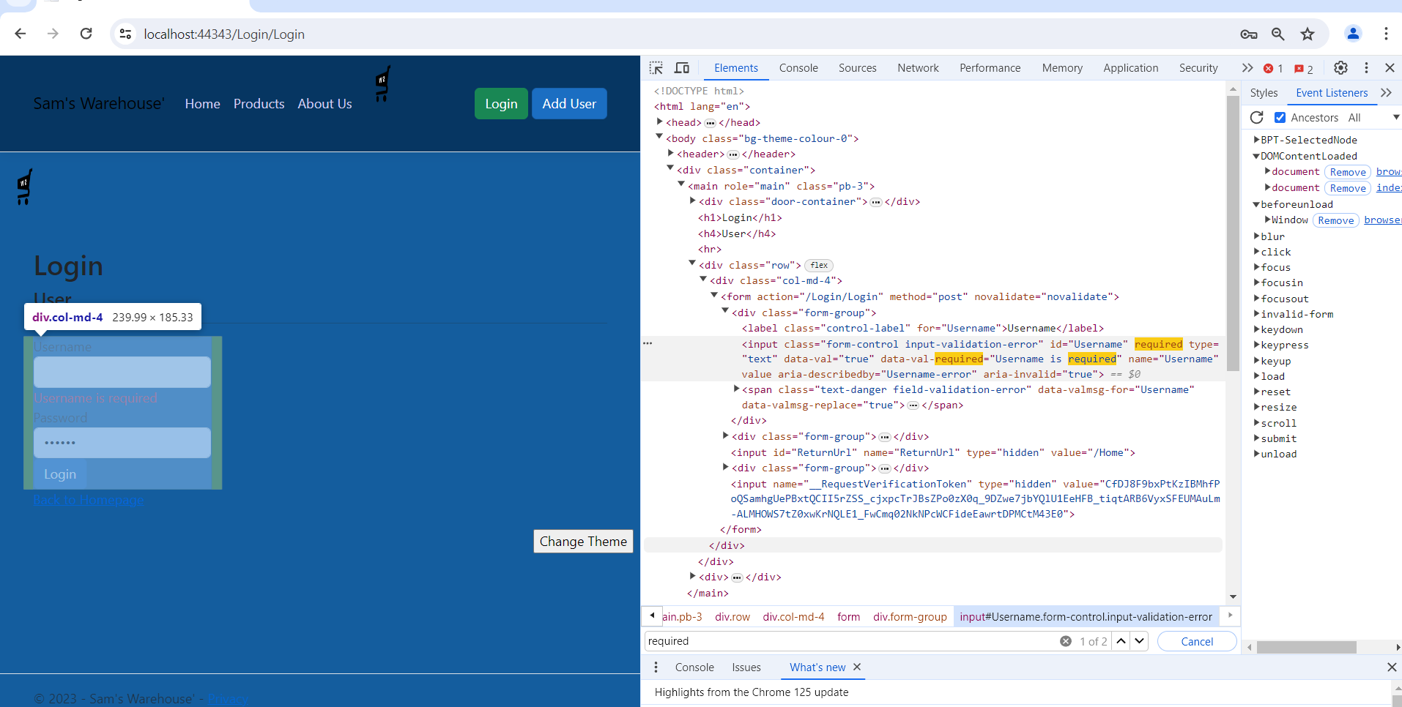

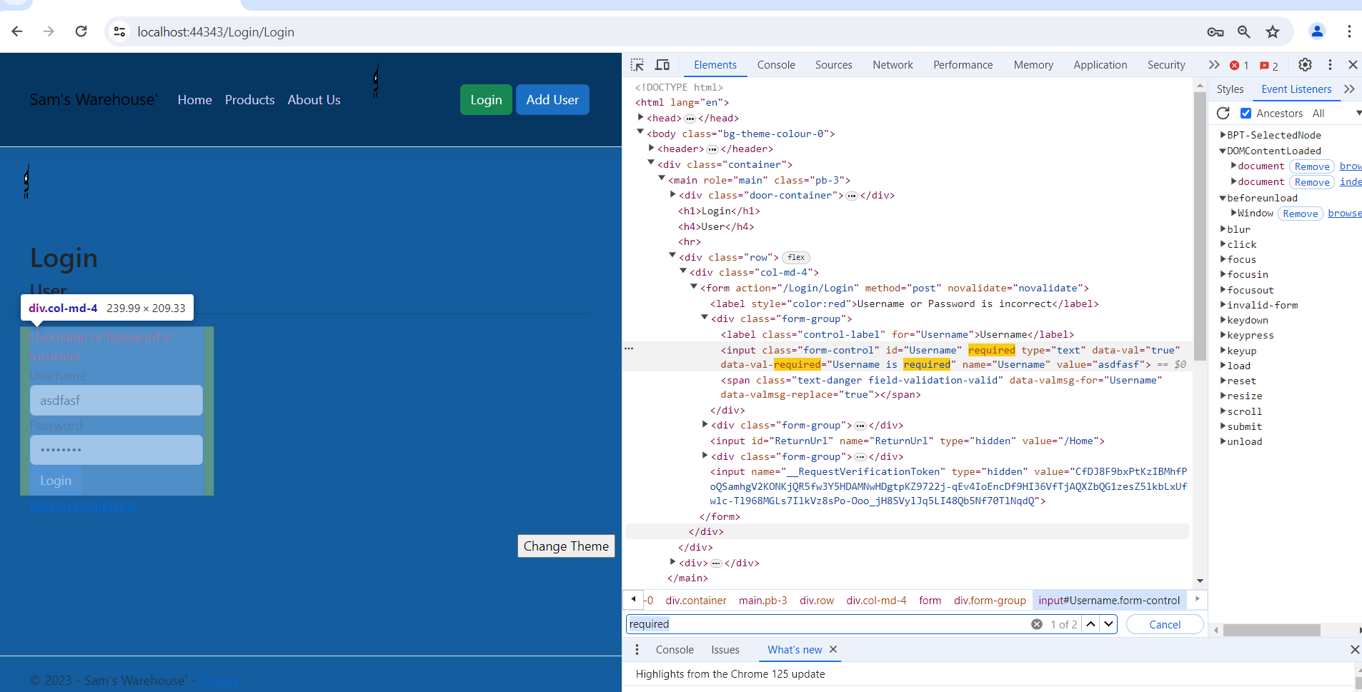

* IDE testing

Description: The image shows the Visual Studio debugger paused on the first line of the Login method in LoginController. You can see the local variables and the execution flow.

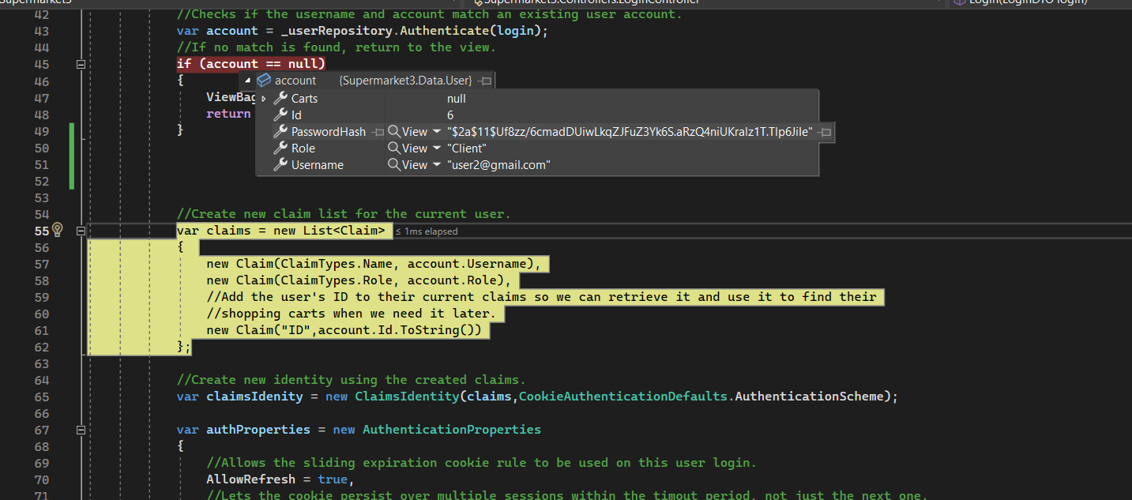

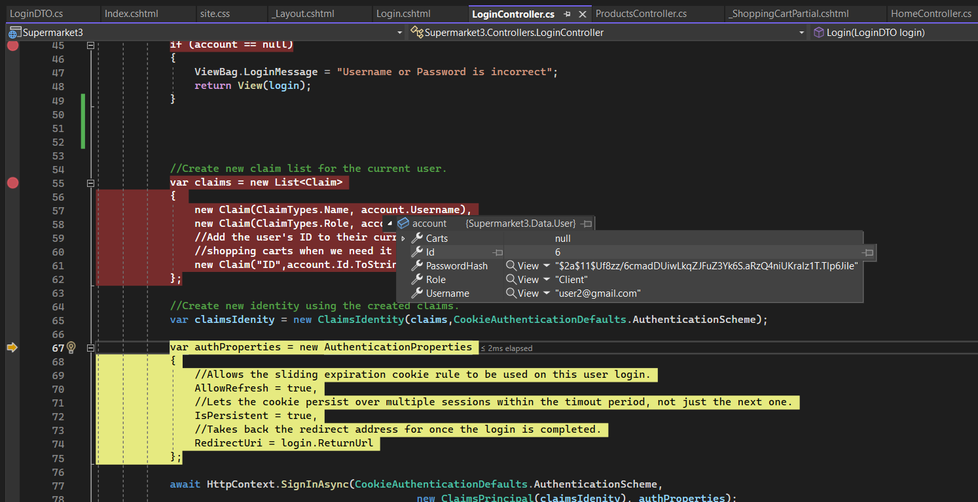

## Model, View + Controller connection Screenshots

* Screenshot of Code demonstrating navigation from one view to another (using controller methods)

This is an image of the page(From the browser) you started on.

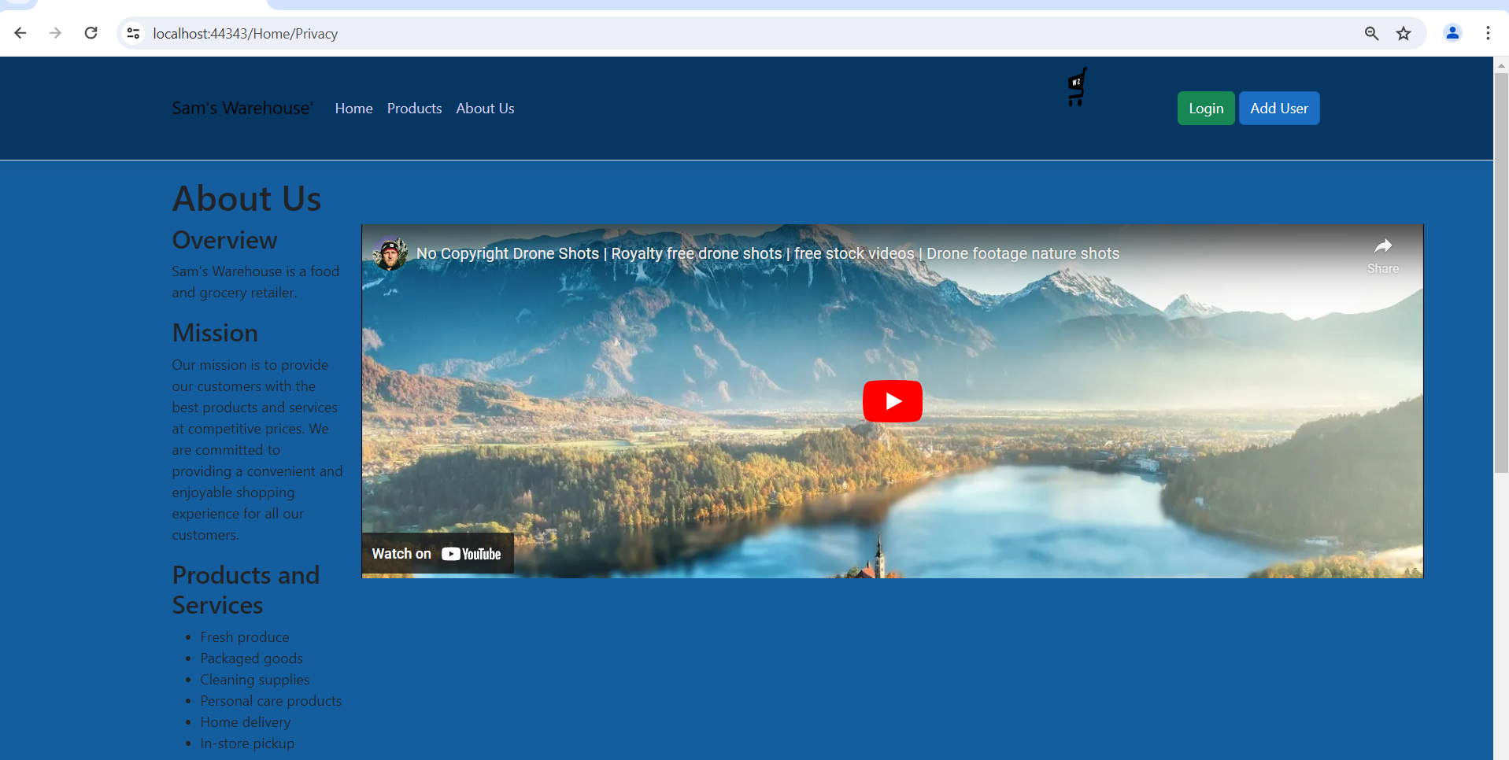

* Screenshot of source code of controller returning generated model data

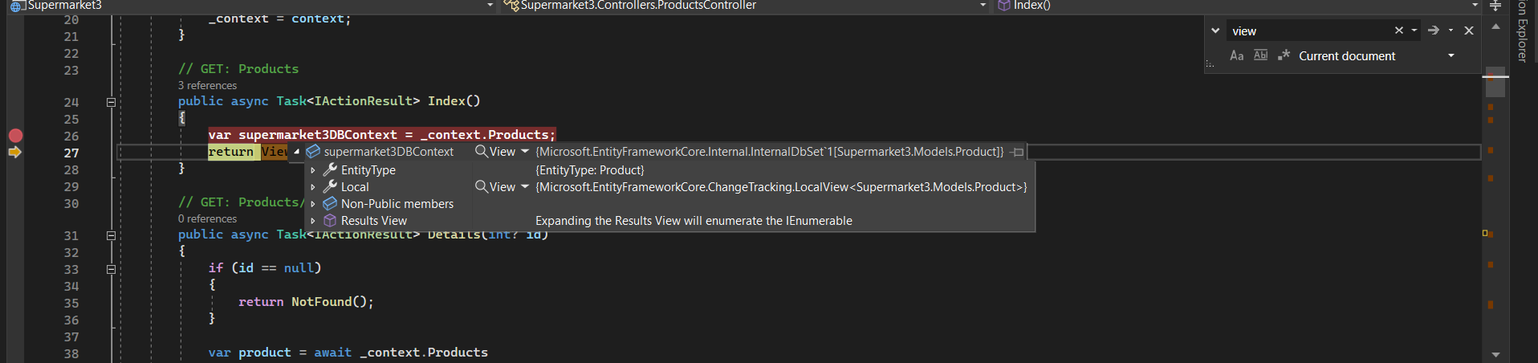

* Screenshot of the view rendering the model data

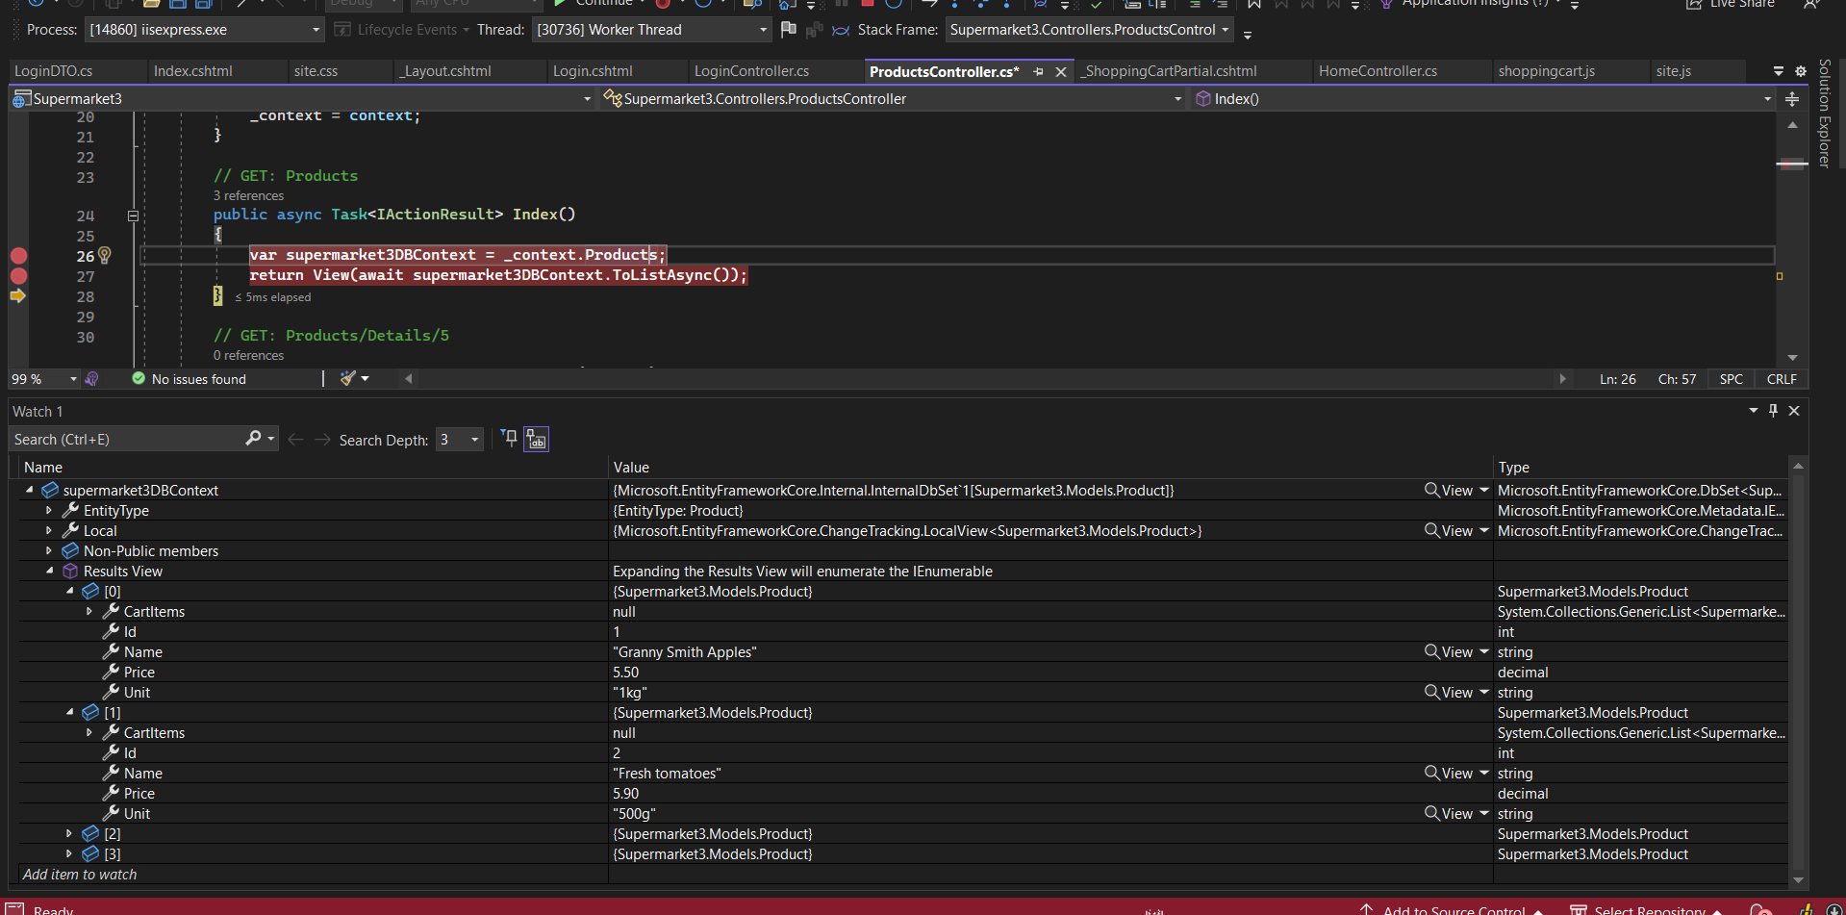

This is an image of the new page(From the browser) that you have navigated to after log in.

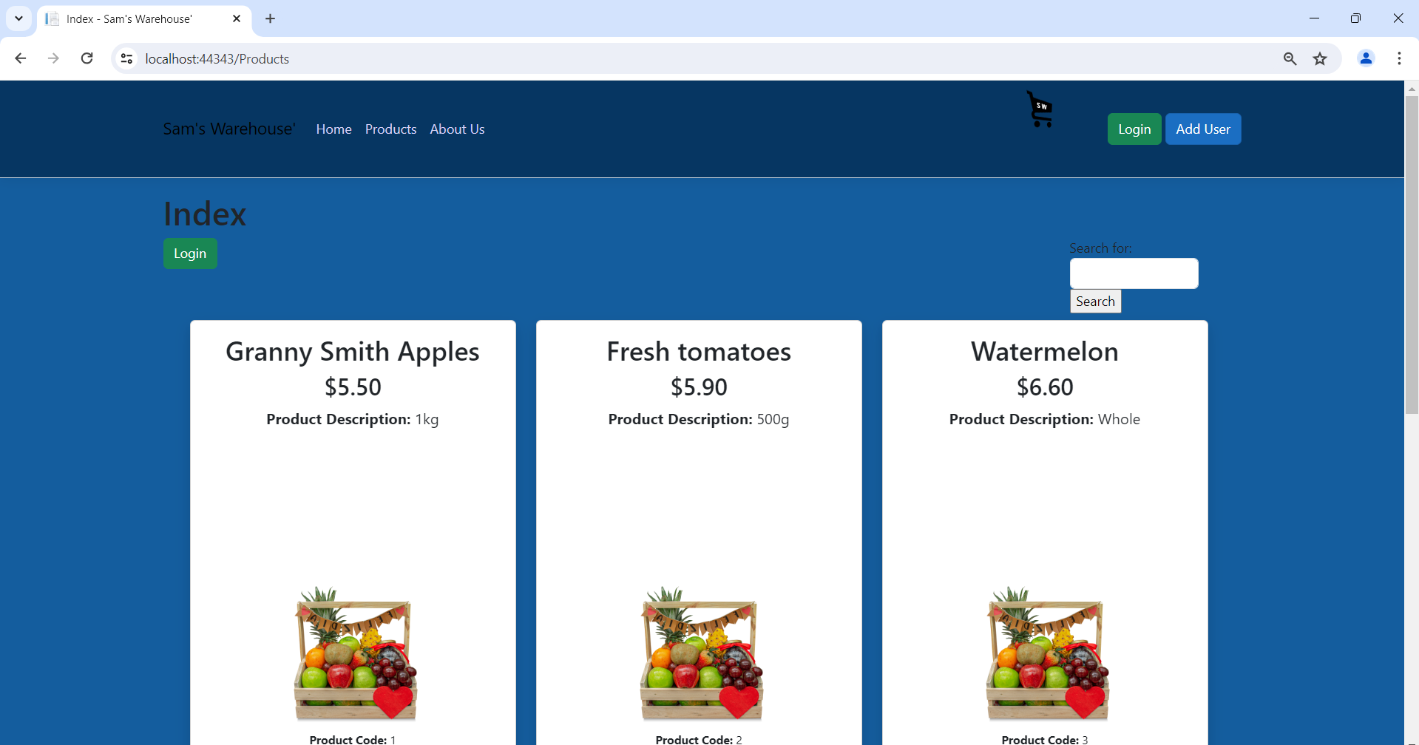

## Client Email demonstrating developed application

Dear Manager;

I hope this email finds you well.

I'm writing to you today to share the progress we've made on developing the SamsWarehouse application. We've been working hard to create a user-friendly and intuitive interface that meets your specific needs and requirements.

Please find attached screenshots of the developed user interface pages. These screenshots provide a visual overview of the application's layout, navigation, and key features.



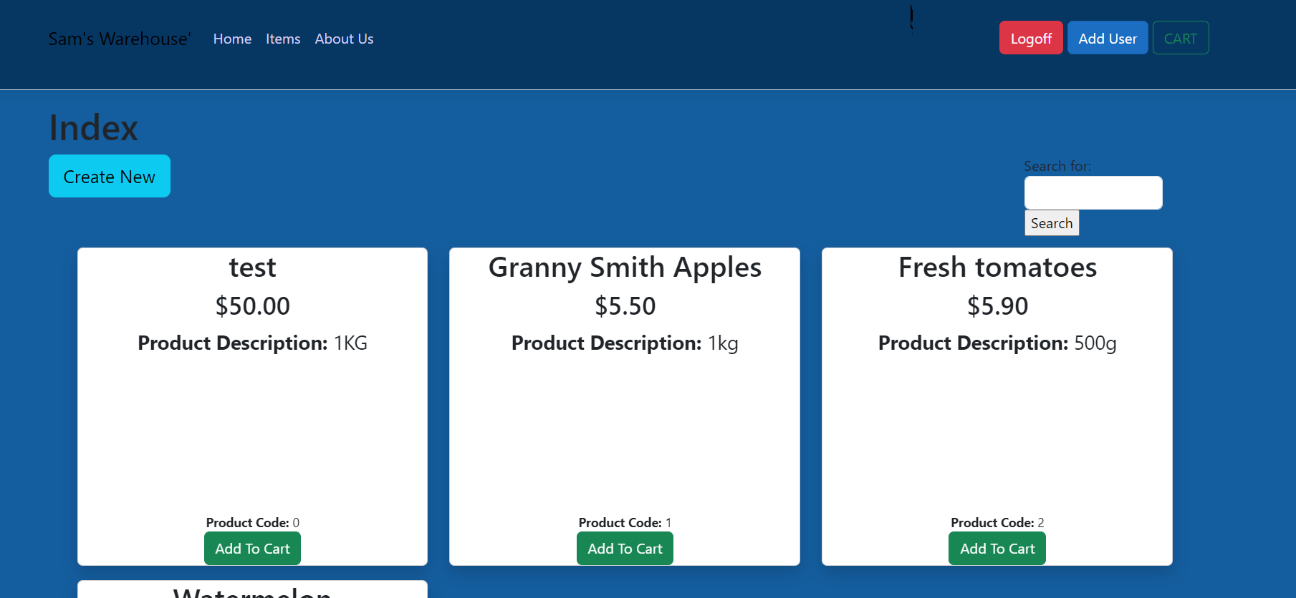

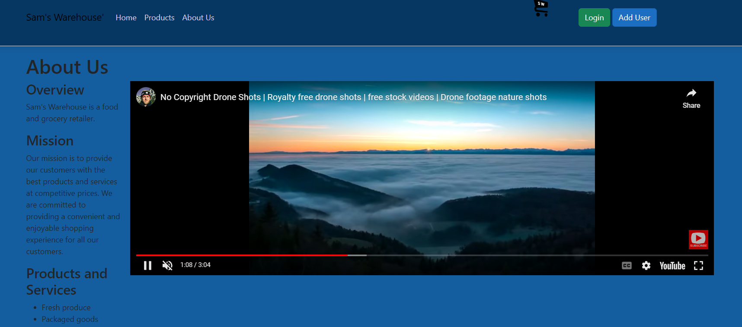

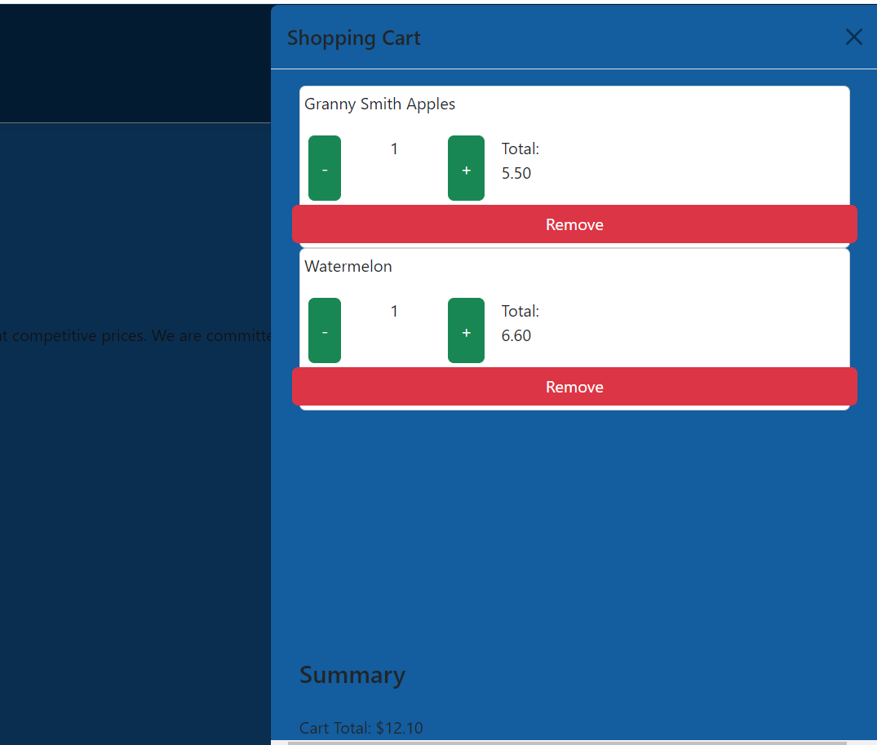

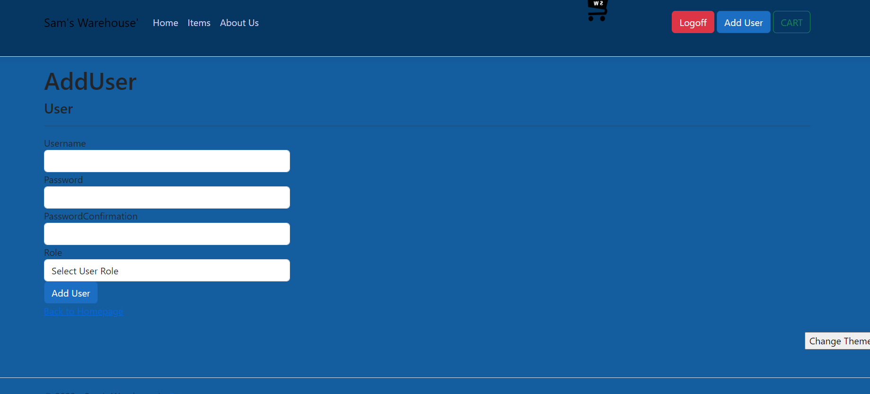

Personalisation and Customisation

We've incorporated several personalisation and customisation features into the application to enhance the user experience. These features include:

User Profiles: Users can create personalized profiles to store their preferences, such as preferred language, units of measurement, and shipping addresses.

Search Functionality: Users can easily search for products using a variety of criteria, such as product name, author, genre, and price.

Product Recommendations: The application recommends products to users based on their past purchases and browsing history.

Saved Items: Users can save items to their wishlist for future reference or purchase.

Order Tracking: Users can track the status of their orders in real time.

Feedback Request

We would greatly appreciate your feedback on the user interface and user experience of the application. Please take some time to review the screenshots and provide your thoughts on the following aspects:

Overall Layout and Design: Do you find the layout of the application to be intuitive and easy to navigate? Is the design visually appealing and consistent across all pages?

Navigation: Is it easy to find the information you need? Are the navigation menus clear and well-organized?

User Interface Elements: Are the buttons, icons, and other user interface elements easy to understand and use? Are the labels and headings clear and concise?

Overall User Experience: Do you find the application to be user-friendly and enjoyable to use? Are there any areas where you think the user experience could be improved?

Please feel free to share your feedback in detail. Your insights will be invaluable in helping us refine the application and make it even better for our users.

Thank you for your time and consideration. We look forward to hearing from you soon.

Sincerely,

Carlos Camacho

## Feedback from the Client/Teacher

Specific Feedback

A specific adjustment to enhance the user experience on the "About Us" page. Currently, the drone video is positioned at the bottom of the page, making it less visible unless the user scrolls down. To improve its visibility and impact, I suggest the following changes:

Move the Drone Video: Position the drone video to the right of the "About Us" details.

Increase Video Size: Make the video at least two times larger to ensure it stands out more prominently.

## Adjustments made to the application to suit feedback

Implemented the changes you requested:

The drone video has been moved to the right of the "About Us" details.

The video size has been increased to be at least two times larger, ensuring it stands out more prominently and is easily noticeable without the need to scroll down.

These adjustments have been made to enhance the visibility and impact of the video content on the page. Please review the changes at your earliest convenience and let us know if there are any further modifications needed.

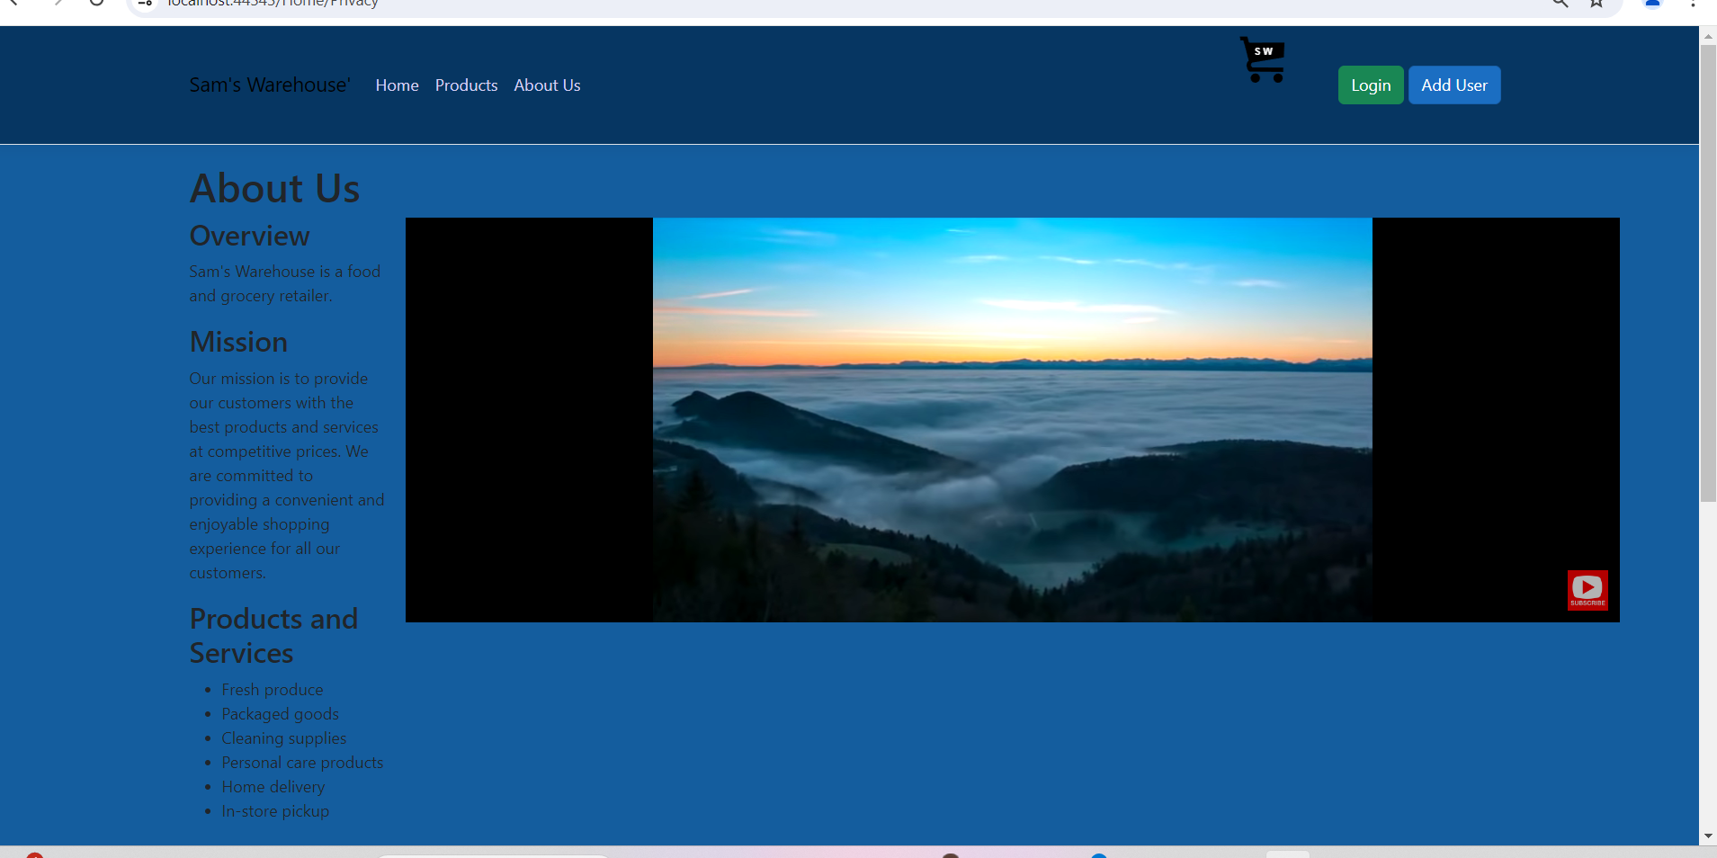

# Part 5 Handoff

## Client Email

*Demonstrating any required changes, confirming development completion*

Dear Manager,

We hope this email finds you well.

We are writing to inform you that the development of the [Project Name] application is now complete. We have incorporated all of your feedback and made the following changes:

Make the About Us page accessible without logging in:

We have modified the application's routing to ensure that the About Us page is accessible without logging in.

We have added a direct link to the About Us page on the home page, making it easily accessible for all users.

Additionally, the drone video on the About Us page has been moved to the right of the details section and its size has been increased to make it more prominent and visible without the need to scroll down.

Please take some time to review the application and let us know if you have any further comments or suggestions. We are always happy to make additional changes to ensure that the application meets your exact needs.

Thank you for your cooperation and support throughout this project. We look forward to hearing from you soon.

Sincerely,

Carlos Camacho

## Sign off sheet

|  |  |  |  |
| --- | --- | --- | --- |
| Project Name: | SamWarehouse | | |
| Project Manager: | Troy | | |
| Start Date: |  | | |
| Completion Date: | 23/05/24 | | |
| Project Deliverables: | | | |
| SamWarehouseApp | | | |
| TECHNICAL REPORT | | | |
|  | | | |
|  | | | |
|  | | | |
|  | | | |
|  | | | |
|  | | | |
|  | | | |
|  | | | |
|  | | | |
|  | | | |
| *I acknowledge that I have submitted all the stated deliverables as per the Project Requirements and your instructions.* | | | |
| Carlos Camacho | | Carlos Camacho | 23/05/24 |
| Developer’s Name | | Signature | Date |
| [Teachers Name] | |  |  |
| Project Manager | | Signature | Date |